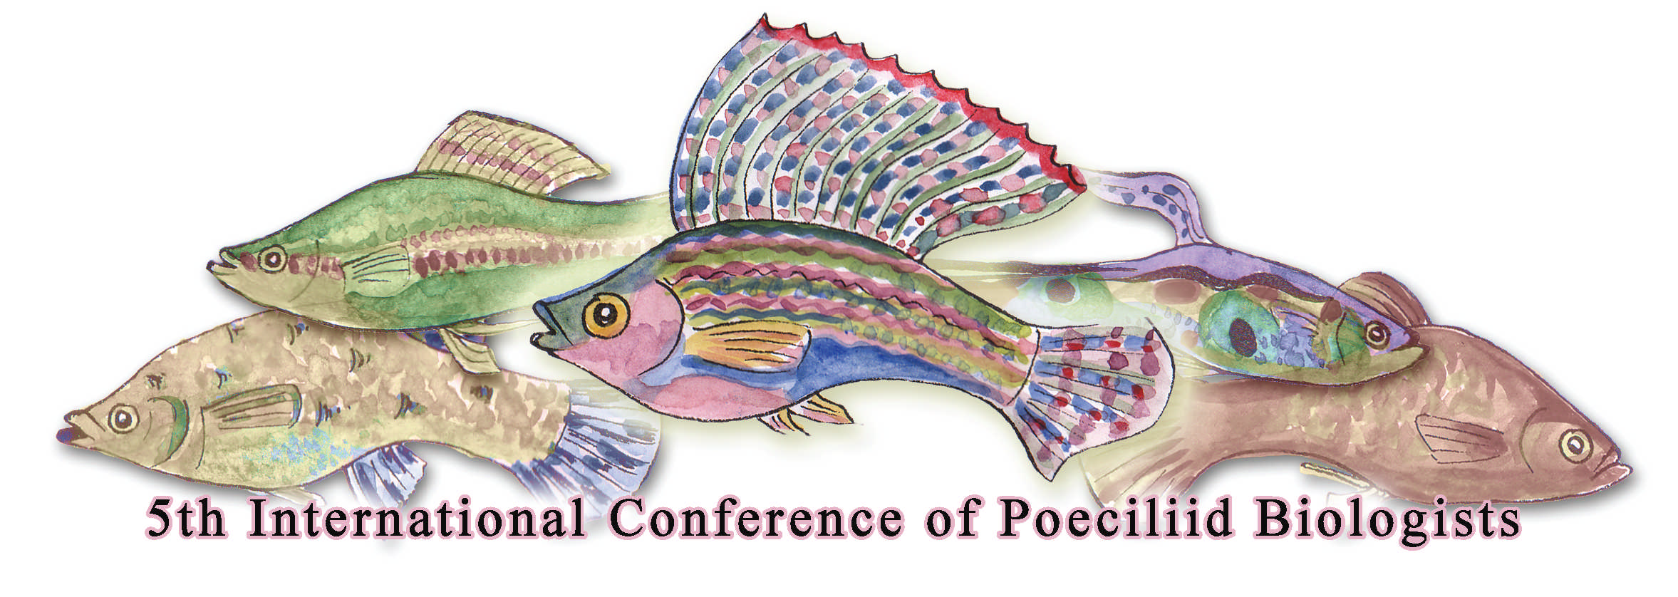
5th International Conference of Poeciliid Biologists: Programme
Monday 25th June 2012
8.00 – 9.00 | Registration
9.00 – 10.00 | Opening ceremony  Welcome by Chair  Remarks by Dean  Remarks by Principal  MSTTE Minister Address
10.00 – 10.30 | COFFEE BREAK
10.30 – 11.15 | Keynote address: Professor Anne Magurran
 | Small is beautiful: Trinidadian guppies and evolutionary ecology
 | Session 1 Invasive Poeciliids 1 Chair: Kit Magellan
11.15 – 11.35 | Amy Deacon
 | How reproductive ecology contributes to the global invasive success of the Trinidadian guppy
11.35 – 11.55 | Craig Sargent
 | Size-Dependent Dispersal in Two Species of Mosquitofish, Gambusia affinis and Gambusia geiseri
11.55 – 12.15 | Doug Fraser
 | Invasion by niche construction: an experimental study of a predatory reversal between stream fish
12.15 – 12.30 | Morelia Camacho-Cervantes
 | Behavioural responses to novel environments
12.35 – 1.50 | LUNCH
 | Session 2 Invasive Poeciliids 2 Chair: Anne Magurran
1.50 – 2.10 | Emili Garcia Berthou
 | On the invasive success and ecological impact of mosquitofish (Gambusia holbrooki) in Europe: what have we learned?
2.10 – 2.30 | Kit Magellan
 | Mosquitofish harassment of native fish and the potential ameliorating effects of artificial refugia
2.30 - 2.50 | Al Reeve
 | Acclimation responses to different thermal regimes by the Trinidadian guppy
2.50 – 3.10 | SESSIONS 1 AND 2: QUESTIONS AND DISCUSSION
3.10 – 3.40 | COFFEE BREAK
 | Session 3: Parasites and Poeciliids Chair: Amy Deacon
3.40 – 4.00 | Jessica Stephenson
 | Parasite distribution among Trinidadian guppy populations
4:00- 4.20 | Felipe Pérez-Jvostov
 | Local adaptation in the context of a mosaic of coevolution: A test with guppies and Gyrodactylus
4.20 – 4.30 | SESSION 3: QUESTIONS AND DISCUSSION

Tuesday 26th June 2012
8.30 – 9.10 | Keynote Address: Professor David Reznick
 | Livebearing – How did it begin and where did it go?
 | Session 4: Life History and Evolution 1 Chair: David Reznick
9.10 – 9.30 | Oscar Rios-Cardenas
 | Differential predation risk of alternative reproductive tactics in a swordtail fish
9.30 – 9.50 | Alexandra Basolo
 | The Effect of Predator Behavior on the Evolution of Platyfish Size
9.50 – 10.10 | Alexander Kotrschal
 | Artificial brain size selection reveals decreased fecundity but increased learning abilities in fish with larger brains
10.10 – 10.30 | COFFEE BREAK
 | Session 5: Life History and Evolution 2 Chair: Doug Fraser
10.30 – 10.50 | Jose Luis Ponce de Leon
 | Life-history strategies of Cuban poeciliid fishes
10.50 – 11.10 | Patricia Frias Alvarez
 | Variation in superfetation and related life-history traits of two Mexican poeciliids: Poeciliopsis infans and P. gracilis
11.10 – 11.30 | Harry Grier
 | The Annual Reproductive Cycle and Its Day Photoperiod Control In Poecilia latipinna (Lesueur, 1821), the sailfin molly
11.30 – 11.50 | Mari Carmen Uribe
 | Structure of the ovarian gonoduct of Poecilia reticulata during non-gestation and gestation phases.
11.50 – 12.10 | Alfredo Ojanguren
 | Transgenerational effects of fatty acid nutrition in western mosquitofish (Gambusia affinis).
12.10 – 1.40 | LUNCH
 | Session 6: Poeciliid Genetics Chair: Indar Ramnarine
1.40 – 2.00 | Eshita Sharma
 | Transcriptome of Poecilia reticulata and comparative analysis for identification of sex-linked loci associated with evolution of the guppy sex chromosomes.
2.00 – 2.20 | Manfred Schartl
 | Genomic consequences of paternal introgression in the Amazon Molly, Poecilia formosa
2.20 - 2.40 | Ronald Walter
 | Aberrant gene expression in Xiphophorus interspecies hybrids
2.40 – 3.10 | COFFEE BREAK
 | Session 7: Poeciliid Genomics Chair: Dawn Phillip
3.10 – 3.30 | Manfred Schartl
 | The Xiphophorus maculatus Jp 163 A genome
3.30 –3.50 | Wesley Warren
 | The genomic investigation of Poecilia formosa
3.50 – 4.30 | SESSIONS 4 – 7: QUESTIONS AND DISCUSSION

Wednesday 27th June 2012
8.30 – 9.10 | Keynote Address: Professor Jens Krause
 | Collective Behaviour and Swarm Intelligence
 | Session 8: Poeciliid Communication Chair: Darren Croft
9.10 – 9.30 | Chris Elvidge
 | Chemical information and risk assessment in guppies: influences of predation risk, experience and context on antipredator behaviours
9.30 – 9.50 | Andreas Svensson
 | Quantifying ornamental carotenoids in male guppies, Poecilia reticulata
9.50 – 10.10 | Karoline Borner
 | Turbidity affects shoaling behaviour and association strength in Trinidadian Guppies
10.10 – 10.30 | COFFEE BREAK
 | Session 9: Social Lives of Poeciliids Chair: Jens Krause
10.30 – 10.50 | Darren Croft
 | Behavioural trait assortment in a social network: patterns and implications
10.50 – 11.10 | Penny Watt
 | Boldness of pairs affects reproductive success in the guppy
11.10 – 11.30 | Amber Makowicz
 | "Poecilia latipinna: The cost of living in a sexual harassment environment"
11.30 – 11.50 | Darren Croft
 | Social preferencesbased on sexual attractiveness: a female strategy to reduce male sexual attention
11.50 – 12.10 | SESSIONS 8 AND 9: QUESTIONS AND DISCUSSION
12.10 – 1.20 | LUNCH
 | Session 10: Sex Lives of Poeciliids 2 Chair: Alexandra Basolo
1.20 – 1.40 | Caitlin Gabor
 | Geographic variation in mate choice in a unisexual-bisexual species complex: are populations consistent?
1.40 – 2.00 | Miguel Barbosa
 | Early social conditions delay the development of sexual behaviour in Trinidadian guppies
2.00 – 2.20 | Raelynn Deaton
 | Comparative effects of female resistance on male mating success across three livebearers with differing mating strategies
2.20 - 2.40 | Heather Auld
 | Male mate-choice copying and the audience effect in the Trinidadian guppy, Poecilia reticulata
2.40 – 3.00 | David Bierbach
 | Audience effects during mate choice of poeciliid males are no aggression avoidance strategies
3.00 – 3.30 | COFFEE BREAK
 | Session 11: Sperm Competition Chair: Alfredo Ojanguren
3.30 – 3.50 | Robin Graber
 | Female preference for novel males in the guppy: does a fresh face matter?
3.50 – 4.10 | Gunilla Rosenqvist
 | Sperm competition in guppies
4.10 – 4.30 | Andrea Di Nisio
 | Evolutionary consequences of producing competitive ejaculates: Insights from an artificial selection study for sperm production in Poecilia reticulata
4.30 – 4.50 | Raelynn Deaton
 | Male mosquitofish alter mating behavior in response to risk of sperm competition
4.50 – 5.10 | SESSIONS 10 AND 11: QUESTIONS AND DISCUSSION

