The Sir Arthur Lewis Institute of Social and Economic Studies
15th Annual Conference
Hyatt Regency Hotel, Port-of-Spain, Trinidad and Tobago
April 23-25, 2014

Caribbean Development: Standing Still or Standing Tall? Theoretical,
Empirical and Policy Challenges

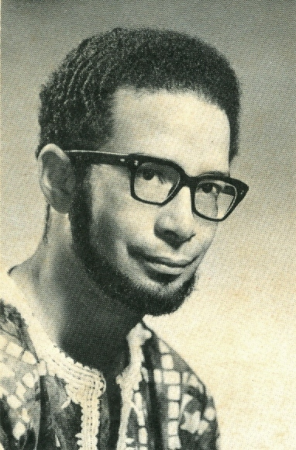
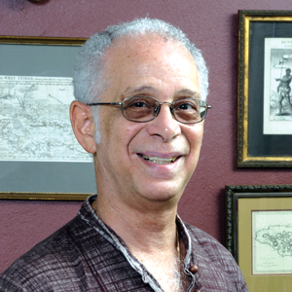
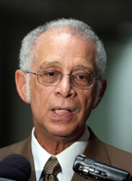
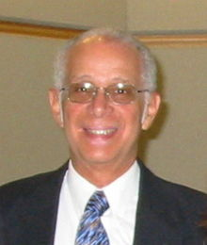
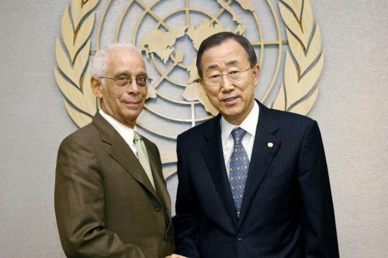
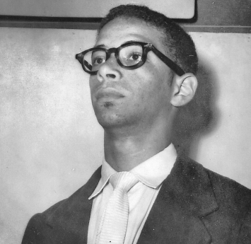

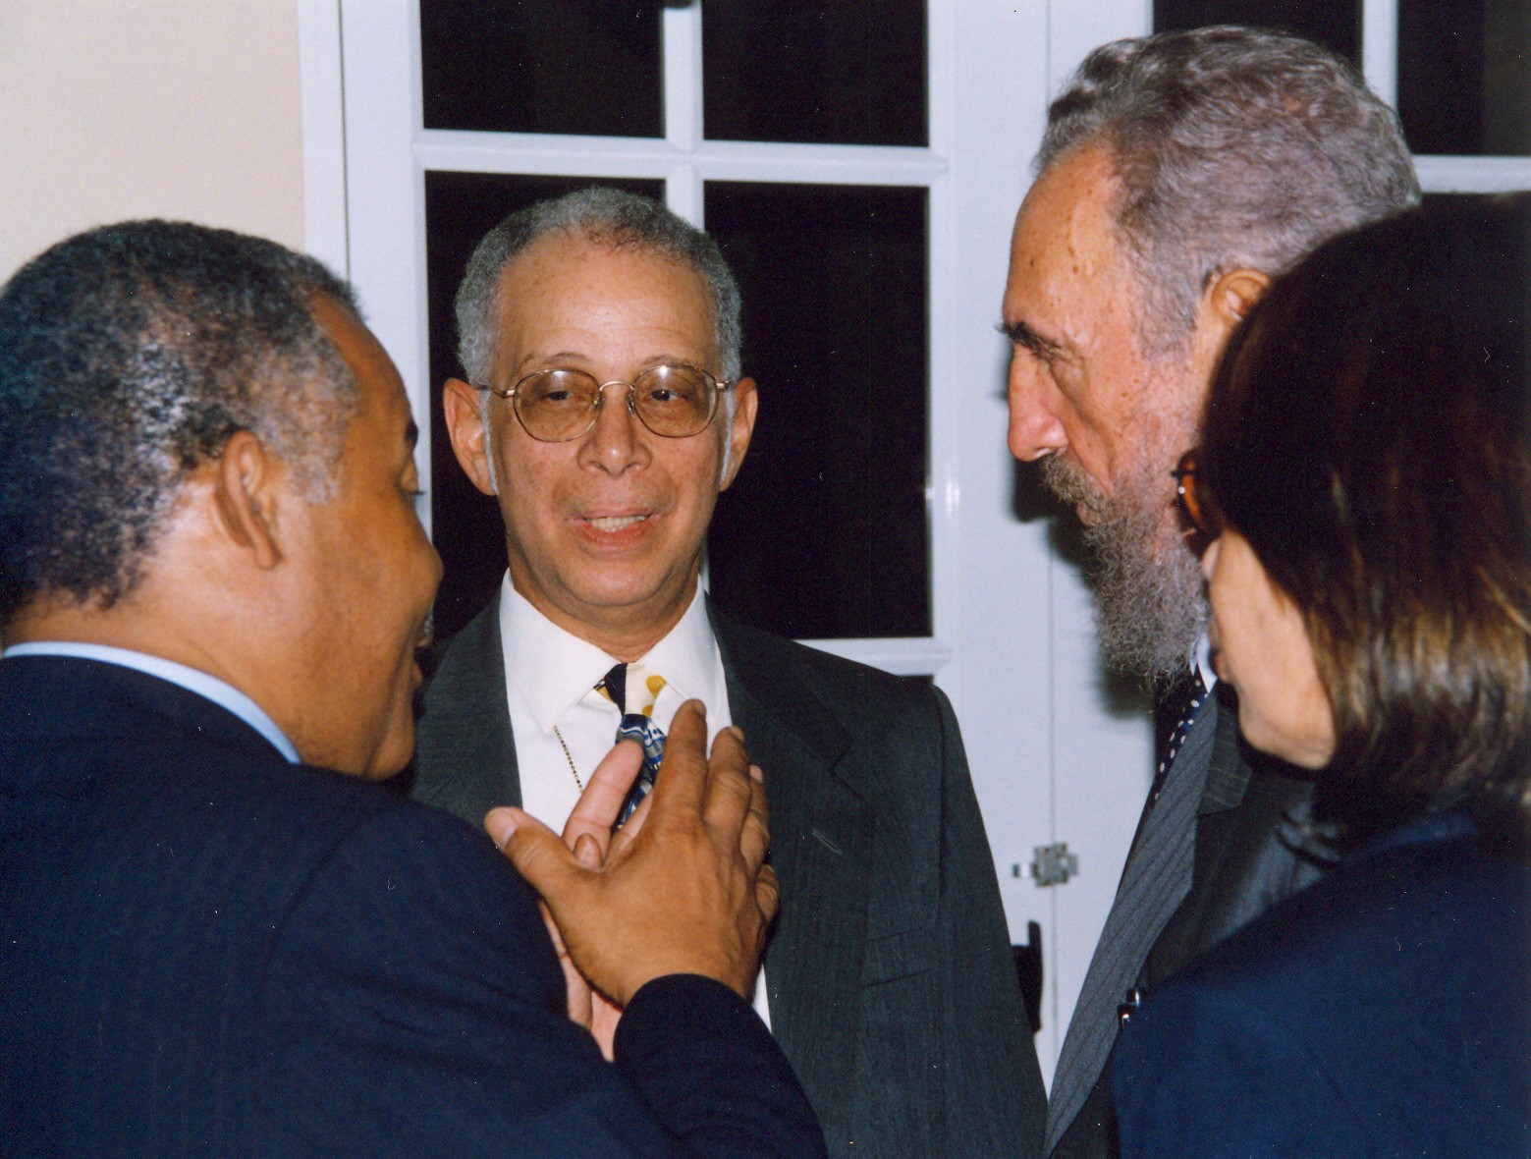
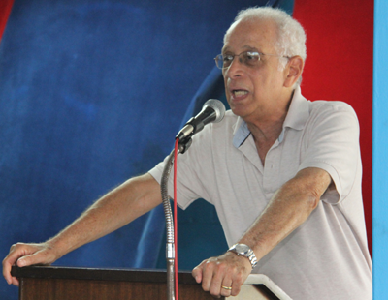
IN MEMORIAM: NORMAN GIRVAN, 1941-2014

DAY ONE: Wednesday 23rd April, 2014
From 7:45 a.m. |  | REGISTRATION  Venue: Topaz
8:30 – 9:45 a.m. | Session 1 A:  Constitutional Reform, Governance, Democracy and Development | Session 1 B:  Productivity, Efficiency, Innovation, Entrepreneurship and Competitiveness | Session 1 C:  Development Theory and Practice Since Arthur Lewis
 | Chair: Patricia Northover  Venue: Jade | Chair: Patrick Watson  Venue: Ruby | Chair: Aldrie Henry-Lee  Venue: Sapphire
 | - Recolonising the Colony - The Case of the Turks and Caicos Islands. Carlyle Corbin  - Beyond Westminster: what does the Caribbean experience teach about more democratic futures? Brian Meeks  - China in Africa: Lessons for the Caribbean? Betty Punnett, and Khaleid Holder  - The Underdevelopment of Development and the Development of Underdevelopment – Trinidad and Tobago at 50+. Godfrey St. Bernard | - Entrepreneurship as a Path to Economic Diversification in Trinidad and Tobago: Insights from the GEM Study. Henry Bailey and Marvin Pacheco  - Exploring an Industry Framework to Evaluate Competitiveness. Joseph Cotton, Reshma Mahabir, and Kevin Smith  - Internal Corporate Social Responsibility (CSR) and Union Militancy in a Small Oil Abundant Economy. Roger Hosein and Roshnie Doon  - Competition Law and Caribbean Development. Kusha Haraksingh | - Cultural Identity and Development in the Caribbean: Some Considerations. Samantha Armorgan  - Integrating Quality Management Principles into Community Development Strategy for improved sustainability and efficiency. Christopher Ivan Chinapoo and Pemba Ramdoo  - The University Of The West Indies And Caribbean Economic Development. Andrew Downes, Roger Hosein and Elizabeth Ince  - Moving Barbados Forward. Jay Mandle
9:45 a.m. – 10:00 a.m. | Coffee Break  Venue: Foyer
10:00 a.m. – 11:15 a.m. | Session 2 A:  Productivity, Efficiency, Innovation, Entrepreneurship and Competitiveness | Session 2 B:  Macroeconomic Management in Small States | Session 2 C:  Debt and the Multilateral Agencies
 | Chair: Sandra Sookram  Venue: Jade | Chair: Godfrey St. Bernard  Venue: Ruby | Chair: Jimmy Tindigarukayo  Venue: Sapphire
 | - Entrepreneurial Engagement and Perceived Quality of Life: A Qualitative Examination in Trinidad and Tobago. Ayanna Frederick  - Kirznerian and Schumpeterian entrepreneurship in Trinidad and Tobago. Arielle John and Virgil Henry Storr  - A Sustainable Development Connecting Common Wealths: Caribbean and Diaspora. Leeanna Seelochan  - Exploring the link between 'KIDS' and the promotion of shared prosperity, improved living standards and poverty reduction. The case of Trinidad and Tobago.- Andel Nelson and Martin Franklin | - EU Aid Coordination and Aid Effectiveness. – Stephen Dearden  - Blessing? Curse? or Disease?: A Macroeconometric Characterisation of Oil and Gas in a Natural Resource Rich Economy – Scott Mahadeo and Sharon D. Hutchinson  - A Sustainable Development Of Foreign Trade Strategy For The Energy Sector Of Trinidad And Tobago. Jamila Greene  - A critical analysis of fiscal policy in Jamaica, 1965 to 2010. Samuel Indalmanie | - Determinants of Fiscal Performance in Microstates: Evidence on the Impact of Fiscal Rules. Joel Okwuokei  - Resolving Sovereign Debt Distress in the Caribbean – Towards a Heavily Indebted Middle Income Country (HIMIC) Initiative. Jwala Rambarran, Veronica Ramcharan and Michelle Majid  - Sir Arthur Lewis, Unlimited Supplies of Labour and Sustainability. Mahadeo Bissoon  - Creating multi-indicators of poverty: Household Budget Survey and Its Applications. Dindial Ramrattan, Reshma Mahabir and Earl Boodoo
11:15 a.m. – 12:15 p.m. | Plenary  Presenter – Friedrich Schneider  “Shadow Economies in 25 Latin American and Caribbean Countries: What are the Driving Forces?"  Chair: Patrick Watson  Venue: Regency V and VI
12:15 p.m. – 1:45 p.m. | Lunch  Venue: Regency IV
1:45 p.m. – 3:00 p.m. | Session 3 A:  Caribbean Integration In The Development Agenda | Session 3 B:  Children and Youth | Session 3 C:  Vulnerable Populations, Social Exclusion, Poverty and Inequality I
 | Chair: Indira Sagewan-Alli  Venue: Jade | Chair: Eric Strobl  Venue: Ruby | Chair: Michael Brei  Venue: Sapphire
 | - Strategic Integration Options for the Caribbean". Renato Flores  - Is Caribbean Regional Integration A Pipe dream? – Anthony Gafoor  - “We Ready For The Road”: Cultural Possibilities and Challenges For Caribbean Integration. Patricia Mohammed  - Domestic Politics, Caribbean Integration and the Challenge of Change. Indira Rampersad | - Corporal punishment in the Caribbean – attitudes and practices. Corin Bailey, Tracey Robinson and Charlene Coore-Desai  - A Sociology of Childhood for Developing Countries. Aldrie Henry-Lee  - Listening to Children with Disabilities: A Call to Action for Children with Cerebral Palsy in Trinidad and Tobago. Maxine Hunte  - The Curious case of Unemployment in Jamaica: Trends, Incidence and how best to Escape it. Robert Mullings | - Judging the quality of ECCE provision in the rural disadvantaged community of Mayaro. Gayah-Batchasingh and Jerome DeLisle  - Social Capital and Welfare Systems in Barbados and Jamaica. Alana Griffith  - Evaluation of an Outreach Project to Help Homeless People in Jamaica. Jimmy Tindigarukayo  - Baker-Hopkin Model and the Origin of Grameen Bank in Bangladesh. Abu Wahid
 | Liquid Break is available in from 3:00 p.m. -3:30 p.m. in the Foyer
3:00 p.m. – 4:15 p.m. | Session 4A:  Road Traffic Issues in Trinidad and Tobago - Situation and Change in a Development Context | Session 4B:  Macroeconomic Management in Small States | Session 4 C:  Financial Structures and Financial Regulation in Small States.
 | Chair: Eric Strobl  Venue: Jade | Chair: Sandra Sookram  Venue: Ruby | Chair: Prof Selwyn Ryan  Venue: Sapphire
 | - Green Initiatives: Bikes and Other Modes of Green Transport. Toni Blackman  - Attitudes and Practices among Maxi-Taxi Drivers in Trinidad and Tobago – Implications for Road Safety Promotion. – Delena Indar and Godfrey St. Bernard  - Manifestations of Development and its Impact on Road Traffic Fatalities in Trinidad and Tobago. Wendy Sawh and Godfrey St. Bernard.  - Characteristic Features, Temporal Patterns and Lessons To Be Learnt: The Case Of Fatal Road Traffic Crashes In Jamaica And Trinidad and Tobago. Godfrey St. Bernard | - Offshore Financial Centers and Round-Tripping. Michael Brei  - Corporate Governance: What is an Appropriate Model for Emerging Market Economics? Jehann Jack  - Does Firm Growth Reduce Shareholder Wealth? George Saridakis and Andrew Vivian  - An estimation of the government spending multiplier and fiscal stance in the Caribbean 1990-2011. Karl Malgarejo | - Discovering an Advantage Point in the contribution of E-learning to Business Performance Improvement: A Case Study in the Insurance  Sector. Darren Gosine and Fiayaz Shaama  - Assessing the Resilience of the Banking System in Trinidad and Tobago: A Vector Auto-regression Analysis. – Akeem Rahaman, Reshma Mahabir and Earl Boodoo  - Technical analysis in Caribbean stock markets. Varuna Ramlal and Patrick Watson  - The State Of Development of Bond Markets In Barbados, Jamaica And Trinidad And Tobago. Antoinette Stewart-Aché and Patrick Watson
7:00 – 9:30 p.m. | Opening Ceremony  Feature Address: Rt. Hon. Sir Charles Michael Dennis Byron  President  Caribbean Court of Justice  Venue: Regency V and VI  Cocktail Reception  Venue: Regency I and II

Opening Ceremony
Chair – Professor Patrick Watson
Director, SALISES (St. Augustine)
Opening Remarks
Professor Brian Meeks
University Director, SALISES
Welcome
Professor Clement Sankat
Principal
The University of the West Indies, St. Augustine
Remarks
Mr. Errol Simms
Dean, Faculty of Social Sciences
Feature Address
Rt. Hon. Sir Charles Michael Dennis Byron
President, Caribbean Court of Justice
Closing Remarks
Dr. Judy Whitehead
Director, SALISES (Cave Hill)

DAY TWO: Thursday 24th April, 2014
7:45am - 12:00 noon | REGISTRATION  Venue: Topaz
8:30 a.m. – 9:45 a.m. | Session 5 A: Judy Whitehead  Climate Change in Small States I | Session 5 B:  Macroeconomic Management in Small States | Session 5 C:  Gender, Health, Ageing And Disability
 | Chair:  Venue: Sapphire | Chair: Godfrey St. Bernard  Venue: Ruby | Chair: Aldrie Henry-Lee  Venue: Regency V
 | - Mapping Roxborough’s Local Knowledge, using P3DM, to Support the Development of Climate Change Strategies and Policies Amit Seeram and Michael Sutherland  - Making Regionalism Pro Youth and Pro Poor- The Missing People Factor. Juliana Foster  - Climate Change Awareness at the Micro Level: Case study of Grande Riviere, Trinidad Sherry-Ann Ganase and Sandra Sookram  - Mainstreaming Gender and Age Dynamics in Rural Development and Climate Change Adaptation Programmes- Insights from the USAID Ja Reach Project. – Leith Dunn, Patricia Northover and Lloyd Waller | - Evolving Caribbean Economic Development Thought and the Economic Partnership Agreement between the CARIFORUM and the EU. Rebecca Gookool, Roger Hosein and Jeetendra Khadan  - Evolving Perceptions On Export Led Growth and the Direction of Causality with Reference to Trinidad and Tobago. – Roger Hosein, Jeetendra Khadan and Nirvana Satnarine-Singh  - The Determinants of Economic Growth in the Countries of the Organization of the Eastern Caribbean States. Nlandu Mamingi  - Caribbean Diversification and Development. Preeya Mohan and Eric Strobl | - Female Entrepreneurship in the Caribbean: Experiences of Inclusion and Exclusion. Talia Esnard  - Baby Mama Talks: Motherhood in Childhood Caribbean Style. Paula Morgan  - Health, Ageing and Disability in Trinidad and Tobago. Pemba Ramdoo  - Invisible immigrants: A Profile of Irregular Migration, Smuggling of Migrants and Trafficking in Persons in Trinidad and Tobago. Leigh-Ann Waldropt-Bonair Juliana Foster, Gerard Gray, Susan Alfonso and Torshia Seales
9:45 a.m.– 10:00 a.m |  | Coffee Break  Venue: Foyer
10:00 a.m. – 11:00 a.m. | Session 6 A:  The Environment: Coastlines, Fisheries, Forests, Biodiversity | Session 6 B:  Climate Change in Small States II | Session 6 C:  European Law
 | Chair: Ronald Ramkissoon  Venue: Sapphire | Chair: Selwyn Ryan  Venue: Ruby | Chair: Mr Kusha Haraksingh  Venue: Regency V
 | - The greening of hotels in Barbados: benefits, challenges and recommendations. Rico Knight Janice Cumberbatch  - Green Economy: Catalysing and supporting sustainable small, medium and micro enterprise development in the Caribbean. Sarah McIntosh  - Rethinking Caribbean Economic Development: Exploring a Green Economy Approach. Loiza Rauzduel and Nicole Leotaud | - Fresh Water Resources and Water Governance in Saint Lucia. Sharon Hutchinson, Michelle Mycoo, Sandra Sookram, Michael Sutherland and Patrick Watson  - Multi-Hazard Evaluation of Vulnerabilities Affecting Freshwater Availability in Caribbean SIDSs. Mattia Amadio and J. Mysiak  - Creating a Livelihood Vulnerability Framework for Small Island Developing States. Sharon Hutchinson, Patrick Watson and Sandra Sookram | - Implementation Of The Optional Protocol To The Un Convention Against Torture In Overseas Territories With Specific Attention To The Caribbean Antenor Hallo de Wolf  - EU Law in the Caribbean: Learning From Bancoult. Dimitry Kochenov  - Caribbean States And Legal Relations With The European Union Morten Broberg
11:00 a.m. – 12:15 p.m. | Session 7 A:  Crime, Violence and Regional Security I | Session 7 B:  Migration, Remittance/Vulnerable Populations | Session 7 C:  Vulnerable Populations, Social Exclusion, Poverty and Inequality
 | Chair: Frederick G. Allen  Venue: Sapphire | Chair: Corin Bailey  Venue: Ruby | Chair: George Saridakis  Venue: Regency V
 | - Crime Control in Jamaica: Challenges for the Police and Community. Frederick Allen  - Roots of Violence In Trinidad: How Ethnic Disparities, Political Animosities, and The Growing Drug Trade Have Impacted Crime Rates. Simone Martin  - Temporal Change in Homicide Frequency in Trinidad and Tobago 2000-2012: A Time Series Analysis. Godfrey St. Bernard  - Remedying deficiencies within the Criminal Justice System in Trinidad and Tobago as a precursor to development. Wendell Wallace and Sheridon A. Hill | - Migration in Trinidad and Tobago – Harnessing the Developmental Potential of a Hidden Resource Leigh-Ann Waldropt-Bonair and Jewel Thomas-Alli  - Do Remittances Help Smooth Consumption during Unexpected Shocks? Diether W. Beuermann, Inder Ruprah Ricardo E. Sierra  - Sport and Social Development in the Caribbean. Anand Rampersad  - Community Based Ecotourism and Poverty Alleviation in Grande Riviere: A Contingent Valuation Approach. Sean Scott and Roger Hosein | - Social Exclusion, Poverty and Inequality. What role for civil society in the Caribbean, with particular emphasis on Trinidad and Tobago? Earla Alcide and Annita Montoute  - Getting Progress Right: Measuring Progress towards the MDGs against Historical Trends. Simon Lange  - Poverty, Education and Occupations: The Case of Sangre Grande. Nyron Seaton  - Poverty Is An Economic Crime Not A Moral Sin: Issues Of Globalized Food Production and Hunger In The Caribbean. Theresa Rajack-Talley
12:15 pm - 1:30 p.m. | Lunch  Book Launch  Caribbean Renewal: Tackling Fiscal and Debt Challenges  Charles Amo-Yartey  Venue: Regency IV
1:30 p.m. – 2:45 p.m. | Session 8 A:  Financial Structures and Financial Regulation in Small States II | Session 8 B:  Health, Gender, Ageing and Disability II | Session 8 C:  Natural Disasters And Disaster Preparedness
 | Chair: Patricia Northover  Venue: Sapphire | Chair: Indera Sagewan-Alli  Venue: Ruby | Chair: Jimmy Tindigarukayo  Venue: Regency V
 | - The Evolution of Explicit Deposit Insurance Systems in the English-Speaking Caribbean in the Period 1986-2011. Denis Cox And Earl Boodoo  - Intra Industry Trade Measurement: Then and Now - Towards a new measure of MIIT. Ranita Seecharran  - Privatization of the National Commercial Bank of St. Vincent and the Grenadines: An Empirical Analysis Using the Tarcsimel Framework. Anthony Wood and Dalano DaSouza  - Dollarisation is the Second Best Option for Small Open Economies. Worrell DeLisle and Peter Whitehall | - Deportee challenges: Investigating the experiences of and coping mechanisms employed by migrants deported to Jamaica. Shamir Henry  - A Flow Measure of Missing Women by Age and Disease. Sebastian Vollmer and Stephen Klasen  - A Community Action Plan to Enhance the Quality of Life of Persons with Autism in Trinidad and Tobago. – Teresina Sieunarine  - The Impact of Migration on the Economic, Political and Social Development of Small States: A Case of the Dominican Republic. Nicholas Sookhoo | - Do Tropical Storms drive Inflation? An Investigation of the Caribbean. Anthony Birchwood, Eric Strobl and Mr. Regan Deonanan  - Blood Transfusion Services in the Caribbean. Are we prepared for a disaster? Kenneth Charles  - Coping with Extreme Weather Events in Small Island Developing States: The Case of SIDS in the Caribbean and South-West Indian Ocean. Jonathan Lashley  - ACS and the Importance of Institutional Cooperation in the Practice of Disaster Risk Reduction. George Nicholson, Nayaatha Taitt, Kaliyma Boxill and Sabine Louis-Gustave
2:45 p.m. –  3:00 p. m. | Liquid Break  Venue: Foyer
3:00 p.m. - 4:15 p.m. | Session 9 A:  Health, Gender, Ageing and Disability | Session 9 B:  Vulnerable Populations, Social Exclusion, Poverty and Inequality | Session 9 C:  The Environment: Coastlines, Fisheries, Forests, Biodiversity
 | Chair: Jonathan Lashley  Venue: Sapphire | Chair: Paula Morgan  Venue: Ruby | Chair: Sharon Hutchinson  Venue: Regency V
 | - Incorporating Quality Adjusted Life Years (QALYs) into Resource Allocation Decisions in Trinidad and Tobago. – Henry Bailey  - Improving Life Chances of an “At Risk” Group in Trinidad and Tobago: An Exploratory Analysis of Missing Girls’ Data. Melissa Berkley and Godfrey St Bernard  - Healthcare Access Challenges: Multi-Island Micro Caribbean States. Roxanne Brizan-St.Martin and Althea La Foucade  - On standing still: Research and Policy on Educational Inequality in the Republic of Trinidad and Tobago. Jerome DeLisle | - Am I disabled or are you? Jean Antoine-Dunne  - Haiti: Away from Social Vulnerability (Inequality, social exclusion and poverty level)? (1994-2014). Claude Beauboeuf  - Towards more efficient measurement and targeting for the eradication of Child Poverty in Trinidad and Tobago. Juliana Foster, Gary Tagallie, Janine Xavier, Deryn Carter-Rene and Adesh Sadeo  - The Participation of the Poor in Universal Social Assistance in Trinidad and Tobago. Raynata Wiggins and Sandra Sookram | - Environmental Pollution and Biodiversity:  Light Pollution and Sea Turtles in the Caribbean. – Michael Brei, Eric Strobl and Agustin Perez Barahona  - The Economic Impact of Climate Change on Energy Demand in Jamaica. Alecia Evans and Sidonia McKenzie  - Birds on the EDGE: Setting Avian Biodiversity Conservation Priorities in Trinidad and Tobago. Eric Strobl  - Water demand: Correlation of BWA Water Consumption with Socioeconomic and Climatic Variables for Christ Church and St. Phillip, Barbados from 2000-2012. Giselle Volney
7:00 – 9:30 p.m. | Sir Arthur Lewis Distinguished Lecture  Professor Peter Blair Henry  Dean of New York University’s Leonard N. Stern School of Business and William R. Berkley of Economics and Finance  Venue: Regency IV  Cocktail Reception  Entertainment: Mr Noel La Pierre, Pannist  Venue: Jade and Boardroom Terrace

DAY THREE: Friday 25th April, 2014
Time
9:00 a.m. - 10:15 a.m. | Session 10 A:  Constitutional Reform, Governance, Democracy and Development |  | Session 10 B:  Productivity, Efficiency, Innovation, Entrepreneurship and Competitiveness
 | Chair: Roger Hosein  Venue: Toco |  | Chair: George Saridakis  Venue: Sangre Grande
 | - Monetary Policy and the Business Cycle - Ong A Kwie and Ansjela-Devi Bhagwandin  - Economic Integration in the English Caribbean and Economic Growth and Development: With Special Emphasis on the SIDS of the OECS. Clarence Henry  - Challenges and Opportunities For More Integrated Food Security Policy and Governance in the Caribbean Community. Kristen Lowett, Arlette Saint Ville, Caroline Keddy, and Gordon M. Hickey  - Fiscal Policy under natural resource dependency: The Case of Suriname. Tjon Kie Sim, Albert Mungroo and Harry Dorinnie |  | - The factors preventing Micro and Small Enterprises (MSE) from accessing non-credit Business Development Services (BDS) in Jamaica. Sean Ffrench  - Full Breed Stallions: Growing Entrepreneurs in College. Guido Rojer  - Towards a better understanding of strategic planning in service vs. manufacturing firms. Trevor Smith  - Urbanisation and Entrepreneurship in the African Diaspora in the US and Caribbean – Detroit and Laventille Comparison. Keron Victor and Ralph Henry
10:15 a.m. - 10:30 a.m. | Coffee Break  Venue: Toco, Sangre Grande and Foyer
10: 30 a.m. - 11:30 a.m. | Session 11 A:  Cultural Industries in Small States | Session 11B:  Natural Disasters And Disaster Preparedness /Poverty
 | Chair: Paula Morgan  Venue: Toco | Chair: Indira Sagewan-Alli  Venue: Sangre Grande
 | - Adding objective probability information to subjective probability perception: Effects on Lottery Participation in Rural Thailand – Julianna Zenker Andreas Wagener, Sebastian Vollmer  - A Single Market for Cultural and Creative Products in the Caribbean: An Idea whose Time has come – Allain Maurin and Patrick Watson  - Festival Economic Impacts on Small Developing Economies: A Case Study of Grenada’s Spice Mas – Joanne Tull | - How much do we Know? An Examination of Disaster Preparedness in Two Communities in Trinidad. – Fareena Alladin  - Caribbean Hurricane Risk Assessment and Expected Damage. – Preeya Mohan and Eric Strobl  - ACS and its Policy Response to the risk of Hyo-meteorological Events in the Caribbean Region. George Nicholson, Martti Heikinheimo and Nayaatha Taitt
11:30 p.m. – 1:45 p.m. | Lunch and Closing Ceremony  Venue: Port of Spain Ballroom
7:00 p.m. – 12 midnight | Lime at the PCS Nitrogen Silver Stars Panyard  Tragarete Road, Port of Spain  (Finger foods, steel pan music, Popular live entertainment)

