
LECTURER IN COMPUTER SCIENCE

Be part of a Great West Indian Tradition
The University of the West Indies (UWI) is well‐established independent University that serves mainly the English‐speaking territories of the West Indies. These countries listed hereunder all contribute to the UWI:
Anguilla, Antigua & Barbuda, Bermuda, The Cayman Islands, The Commonwealth of the Bahamas, Barbados, Belize. The British Virgin Islands, The Commonwealth of Dominica, Grenada, Jamaica, Montserrat, St. Christopher & Nevis, St. Lucia, St. Vincent & the Grenadines, The Republic of Trinidad & Tobago, Turks and Caicos.
Our annual output of graduates, Caribbean‐focussed research and policy advice provided to governments and the private sector, continue to have a profound influence on the English‐speaking Caribbean, contributing to the region’s stability and its relative wellbeing.

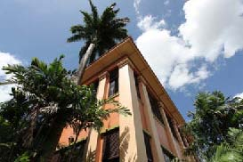

OUR HISTORY
The UWI is the oldest, fully regional institution of higher learning in the Commonwealth Caribbean.
The UWI began at the Mona Campus, Jamaica, in 1948 as a College of the University of London; and in 1962 achieved full university status. The St. Augustine Campus in Trinidad and Tobago was established in 1961 and in 1963 a third Campus was established at Cave Hill in Barbados. In 2008 The University established a fourth Campus – The Open Campus – to better manage and expand multi‐mode delivery of its programmes.
OUR FACULTIES
The seven faculties of The UWI offer a wide range of Undergraduate, Master’s and Doctoral programmes in Food & Agriculture, Humanities & Education, Engineering, Law, Medical and Veterinary Sciences, Science & Technology; and Social Sciences. Several of these programmes are delivered through the distance mode.
Visit us online at www.uwi.edu to find out more about The UWI or www.sta.uwi.edu for more on the St. Augustine Campus and the region we serve!



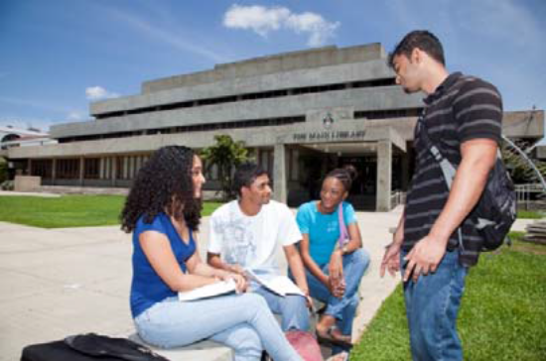

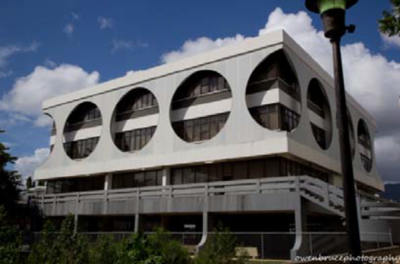

THE ST. AUGUSTINE CAMPUS, FACULTY OF SCIENCE & TECHNOLOGY

The Faculty of Science & Technology was formed in 2012 by a de-merger from the former Faculty of Science & Agriculture. It comprises the departments of Chemistry, Computing & Information Technology, Life Sciences, Mathematics & Statistics, and Physics.
The Faculty of Science & Technology offers Bachelor of Science degrees with majors or specializations in Actuarial Science, Alternative Energy Technology, Biochemistry, Biology, Biomedical Technology, Biotechnology, Botany, Chemistry, Chemistry and Management, Computer Science, Computer Science with Management, Ecology & Environmental Biology, Environment and Natural Resource Management, Environmental Science & Sustainable Technology, Environmental Technology, Information Technology, Information Technology with Management, Marine Biology, Mathematics, Mathematics & Applied Statistics, Microbiology, Plant Biology, Physics, Statistics, Statistics and Economics, and Zoology.
The education objectives of the Department of Computing and Information Technology include the following:
To produce graduates whose professional and academic standards are of a level comparable to their colleagues in the more developed countries and who will function efficiently in whatever environment they are required to work.
The Department of Computing & Information Technology

The Department of Computing & Information Technology is responsible for research and degree programs in the areas of Computer Science and Information Technology. We offer B.Sc. programs in Computer Science, Computer Science & Management, and in Information Technology, and Information Technology with Management. We also offer an M.Sc. in Computer Science and Technology and M.Phil. and Ph.D. research degrees in several exciting research areas of Computing. Teaching and research are supported by state-of-the-art computer laboratory facilities which provide students with hands-on practical experience.

RESEARCH

Limited funds are available for research through the St. Augustine Campus Research and Publication Fund. Members of staff are encouraged to seek external funding. Research can be done during the academic year and during the vacations. All members of staff are expected to engage in research in their field.

Research interests of members of staff include: Decision Support & Geographic Information Systems, eLearning, Networking & Distributed Systems, Wireless Communications, Wireless & Mobile Computing, Mobile Health, Usability, Personalization & Emotive Design, Software Engineering, Data Management & Data Mining, Artificial Intelligence, Intelligent Systems, and Computer Security & Watermarking.

The department has available PCs in each office, 2 large, well-equipped computer labs, a departmental network and internet access.

ESTABLISHMENT

There is provision for the following staff in the Department of Computing & Information Technology:

Academic Staff:
2 Professors (one vacant)
4 Senior Lecturers
7 Lecturers/Assistant Lecturers
1 Network System Administrator
5 Teaching Assistants
9 Demonstrators

Support Staff:
1 Senior Administrative Assistant
1 Senior Research Technician
1 Senior Laboratory Assistant
1 Network Technician
1 Technical Assistant (vacant)

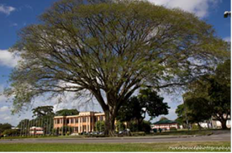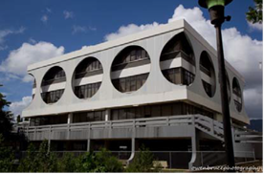
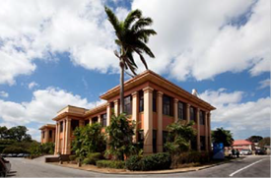
1 Secretary
2 Clerical Assistants
1 Cleaner

PRESENT MEMBERS OF ACADEMIC STAFF

Head of Department: Dr. Permanand Mohan
Margaret Bernard, Senior Lecturer
BSc, MPhil, PhD UWI
Patrick Hosein, Professor
BSc, MSc, EE, PhD MIT
Noel Kalicharan, Senior Lecturer
BSc UWI, MSc Br. Col., PhD UWI
Permanand Mohan, Senior Lecturer
BSc UWI, MSc Sask, PhD UWI
Alexander Nikov, Senior Lecturer
MSc PhD (TU Sofia), Dr. habil. (TU Braunschweig)
Wayne Goodridge, Lecturer
BSc, MPhil UWI, PhD Dalhousie
Michael Hosein, Lecturer
BSc, MPhil UWI, MCSE, PhD UWI
René Jordan, Lecturer
BSc UWI, MSc, PhD Leeds
Duc The Kieu, Lecturer
BSc Vietnam, MSc La Trobe, PhD Taiwan
Salys Lackan, Assistant Lecturer
BSc UWI, MSc, Trento & RWTH Aachen

DUTIES OF APPOINTEE
The appointee will hold a full-time position at the University, with teaching and research responsibilities in the Department of Computing and Information Technology.
The appointee is required to teach a wide range of undergraduate courses in the Computer Science and Information Technology programmes as well as postgraduate courses in the M.Sc. Computer Science and Technology programme. The appointee must also supervise postgraduate students, develop a high quality research programme, attract funding for research programmes, and assist in departmental administration, outreach activities, and curriculum reform.
He/she must be able to work as an effective team member. At all times, he/she must display the highest level of professionalism. He/she shall participate in all routine departmental activities, which include meetings and representation in various committees of the Faculty.
Members of staff may be called upon to deliver teaching in either or both of these modes – blended learning/online as well as face-to-face teaching. Appointees are expected to contribute to teaching and curriculum development in Computer Science and Information Technology at all levels.
Tenure of Appointment – Appointment as Lecturer will normally be for (3) years in the first instance, with eligibility for renewal.
Subsequent to the first appointment, a member of staff who has served in an academic position in this or some other University for a period of six (6) years will be eligible for consideration for appointment on indefinite tenure.
Further details may be obtained from the Registrar, The University of the West Indies, St. Augustine, Republic of Trinidad and Tobago.
Research – Persons appointed to posts in the Faculty of Science and Technology, St. Augustine, will be expected to actively participate in research activities pertaining to his/her field of expertise and/or in collaboration with other departments as appropriate.
FURTHER DETAILS OF THE POST:
Areas of Specialization
Preference will be given to candidates with strong teaching and research experience in Algorithms and Computational Complexity; Artificial Intelligence and Intelligent Systems; Database Systems, Data Analytics, and Big Data; Internet Technologies; Programming and Data Structures; and, Software Engineering and Testing.
Personal Attributes
Candidates should be self-motivated, solution-oriented, and student-centered. They should have excellent communication skills and be able to function effectively as a team player and problem solver. Additionally, they should be keen to interact with stakeholders in industry and in the national and regional communities.
QUALIFICATIONS:
Ph.D. in Computer Science (or related discipline).
EXPERIENCE:
Must have a broad-based background in Computer Science and teaching experience at the University Level (undergraduate and postgraduate)
Excellent interpersonal, oral and written communication skills.
A strong record of research and publication would be an asset.
REMUNERATION PACKAGE

ANNUAL SALARY RANGE:

Lecturer: Minimum: TT$239,544
Maximum: TT$333,456

BENEFITS:
- Special allowance of 6% of basic salary ;
- Transportation Allowance of TT$3,250 per month;
- Unfurnished accommodation at 10% or furnished at 12½% of basic salary, or housing allowance of 20% basic salary to staff making own housing arrangements;
- UWI contribution of equivalent of 10% basic salary to Superannuation Scheme;
- Annual Study and Travel Grant (available after first year of service) – TT$20,717 per annum
- Institutional Visit Allowance – TT$7,200 per annum
- Book Grant TT$6,000 per annum
- Contributory Health Insurance and Group Life Scheme (50%).

The Registry
St. Augustine
File # 187/13/67 II
2017 February 14

