

LECTURER IN SOCIOLOGY

Be part of a Great West Indian Tradition
The University of the West Indies (The UWI) is a well‐established independent University that serves mainly the English‐speaking territories of the West Indies. These countries listed hereunder all contribute to The UWI:
Anguilla, Antigua & Barbuda, The Cayman Islands, The Commonwealth of the Bahamas, Barbados, Belize, Bermuda. The British Virgin Islands, The Commonwealth of Dominica, Grenada, Jamaica, Montserrat, St. Christopher & Nevis, St. Lucia, St. Vincent & the Grenadines, Bermuda, The Republic of Trinidad & Tobago, Turks & Caicos.
Our annual output of graduates, Caribbean‐focused research and policy advice provided to governments and the private sector, continue to have a profound influence on the English‐speaking Caribbean, contributing to the region’s stability and its relative wellbeing.



OUR HISTORY
The UWI is the oldest, fully regional institution of higher learning in the Commonwealth Caribbean.

The UWI began at the Mona Campus, Jamaica, in 1948 as a College of the University of London; and in 1962 achieved full university status. The St. Augustine Campus in Trinidad and Tobago was established in 1961 and in 1963 a third Campus was established at Cave Hill in Barbados. In 2008 The University established a fourth Campus – The Open Campus – to better manage and expand multi‐mode delivery of its programmes.

OUR FACULTIES
The seven faculties of The UWI offer a wide range of Undergraduate, Master’s and Doctoral programmes in Food and Agriculture, Humanities and Education, Engineering, Law, Medical and Veterinary Sciences, Science and Technology; and Social Sciences. Several of these programmes are delivered through the distance mode.

Visit us online at www.uwi.edu to find out more about The UWI or www.sta.uwi.edu for more on the St. Augustine Campus and the region we serve!

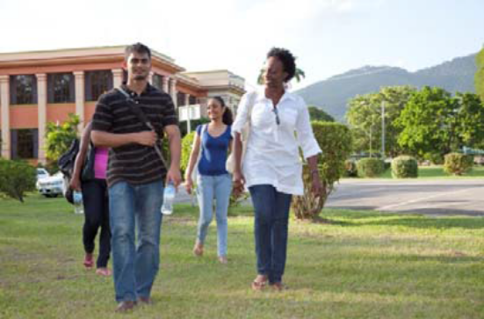

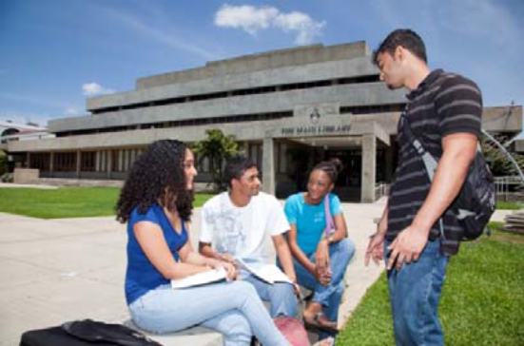

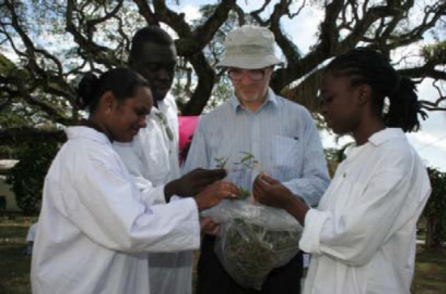

THE FACULTY OF SOCIAL SCIENCES

The Faculty of Social Sciences is comprised of four Departments: Behavioural Sciences, Political Sciences, Economics and Management Studies. There are also a number of research centers and units and a School of Business that are associated with the Faculty of Social Sciences.
The Departments at St. Augustine maintain close collaboration with corresponding Departments or Divisions on the Cave Hill and Mona Campuses.

ESTABLISHMENT

The Department of Behavioural Sciences, in which the position is offered, currently has provisions to accommodate a full-time establishment of 23 academic staff members. The Department also employs several teaching/research assistants to assist the full-time faculty. Tutors are also appointed as necessary to conduct relevant small group tutorials.

PROGRAMME OFFERING

The Department offers the following programmes:

UNDERGRADUATE PROGRAMMES:
SPECIALS
B.Sc. Psychology Special
B.Sc. Social Work Special

MAJORS
B.Sc. Psychology Major
B.Sc. Sociology Major

MINORS
Anthropology Minor
Criminology Minor
Psychology Minor
Social Development Policy and Planning Minor
Social Policy Minor
Sociology Minor

POSTGRADUATE PROGRAMMES

Diploma in Mediation Studies
M.Sc. Mediation Studies
M.Sc. Applied Psychology
M.Sc. Sociology
Master in Social Work
M.Phil./Ph.D. Psychology
M.Phil./Ph.D. Sociology
M.Phil./Ph.D. Social work
M.Sc./M.Phil./Ph.D. Criminology and Criminal Justice

CURRENT MEMBERS OF ACADEMIC STAFF

Derek Chadee - Professor & Head | B.Sc., Ph.D. U.W.I.
Nasser Mustapha – Senior Lecturer  Nicole Albada - Senior Lecturer | B.Sc., M.Phil., PhD., UWI  B.Sc., M.Sc., Ph.D., University of Florida
Innette Cambridge – Senior Lecturer | BA, Moorhead, L-es Soc.,M-es-Soc., Paris, Ph.D., Bristol
Dr. Allan Patenaude – Senior Lecturer | B.A., M.A., Ph.D., Simon Fraser Univ. Canada
Dr. Shelene Gomes - Lecturer | BA, Columbia Univ., USA, MA. Univ. of London, Ph.D. Univ. of St. Andrews, Scotland, UK
Dr. Camille Huggins – Lecturer  Dr Talia Esnard - Lecturer | BA, State Univ. of New York at Buffalo, M.Sc., Columbia Univ., Ph.D., New York Univ.  B.Sc., Ph.D. Sociology, UWI, St. Augustine
Karene-Anne Nathaniel DeCaires - Lecturer | B.Sc. UWI, M.Sc. Rutgers, Ph.D UWI
Dr. Cheryl Ann Boodram - Lecturer | B.Sc. UWI, M.Sc. UWI, Post–Master Cert. NY., Ph.D. UWI.
Emmanuel Janagan Johnson - Lecturer | M.A., M.Phil., Ph.D., Bharathiar University, Coimbatore
Dylan Kerrigan - Lecturer | B.A., Univ. of Sussex, M.A., University of London, Ph.D., American Univ., USA.
Dr. Randy Seepersad - Lecturer | Teachers’ Dip. Corinth Teachers’ College, T&T,  B.Sc. U.W.I., M.Phil., University of Cambridge,  Ph.D., Univ. of Toronto
Dr. Dianne Williams - Lecturer | B.Sc., York College., MBA., High Point Univ. Ph.D., Capella Univ
Dr. Christine Descartes - Lecturer | B.Sc.. Ph.D., PG Cert., UWI
Dr. Jannel Philip - Lecturer  Dr. Maria Gomes – Lecturer | B.Sc.. Ph.D., PG Cert., UWI  B.Sc. UWI, M.Sc. Univ. of London, MSW, Ph.D Howard Univ.
QUALIFICATIONS

PhD in Sociology from a recognized University. Professional qualification in Sociology or related discipline is highly desirable.
AREA OF CONCENTRATION / EXPERTISE
- Ability to teach Research Design and any four (4) or more of the following areas: Health Sociology, Statistics, Qualitative Research Methods, Political Sociology, Industrial Sociology.
- Knowledge of Caribbean Sociology is desirable.

EXPERIENCE

Considerable experience in teaching at the University level and/or in the practice of Sociology at a senior level in industry or in a Sociological environment. Other desirable experience include:
- Success and recognition of professional activities
- Strong publication record and published peer-reviewed research
- Previous graduate supervision experience
- Success and recognition of professional activities

PERSONAL ATTRIBUTES

The Department places high priority on individuals who can work well in a team environment. Candidates should also possess good communication and interpersonal skills and must be student-centered. A good command of both oral and written English is essential. Candidates must also have the:

- ability to work in a multidisciplinary environment
- willingness to develop a research agenda
- ability to be a team player

SPECIAL RESPONSIBILITIES

- Teaching at the undergraduate and graduate level.

- Supervision of post-graduate students

- Involvement in University life (administration, conference organization and committees) and community outreach.

- Contribute to curriculum development

RENUMERATION PACKAGE

ANNUAL SALARY RANGE:

Lecturer: Minimum: TT$239,544.00
Maximum: TT$333,456.00

(US$1.00 = TT$6.50)
BENEFITS:

- Special allowance of 6% of basic salary;
- Transportation Allowance of TT$3,250.00 per month;
- Up to five economy class passages plus baggage allowance of US$3,000.00 (TT$ equivalent) on appointment and normal termination;
- Unfurnished accommodation at 10% or furnished at 12½% of basic salary, or housing allowance of 20% of basic salary to staff making own housing arrangements;
- UWI contribution of equivalent of 10% of basic salary to Superannuation Scheme;
- Annual Study and Travel Grant (available after first year of service); -TT$20,717.00 per annum;
- Institutional Visit Allowance – TT$ 7,200.00 per annum
- Book Grant – TT$6,000.00;
- Contributory Health Insurance – 50%;
- UWI Group Life Insurance.

The Registry
St. Augustine
File #156/35/1 I
2017 May
/JS

