
Senior Lecturer/Lecturer in Geotechnical Engineering

Be part of a Great West Indian Tradition
The University of the West Indies (The UWI) is a well‐established independent university that serves mainly the English‐speaking territories of the West Indies. These countries listed hereunder all contribute to The UWI:
Anguilla, Antigua & Barbuda, Bermuda, The Cayman Islands, The Commonwealth of the Bahamas, Barbados, Belize. The British Virgin Islands, The Commonwealth of Dominica, Grenada, Jamaica, Montserrat, St. Christopher & Nevis, St. Lucia, St. Vincent & the Grenadines, The Republic of Trinidad & Tobago, Turks and Caicos.
Our annual output of graduates, Caribbean‐focused research and policy advice provided to governments and the private sector, continue to have a profound influence on the English‐speaking Caribbean, contributing to the region’s stability and its relative wellbeing.

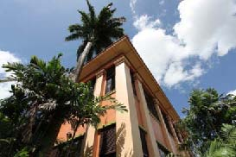

OUR HISTORY
The UWI is the oldest, fully regional institution of higher learning in the Commonwealth Caribbean.
The UWI began at the Mona Campus, Jamaica, in 1948 as a College of the University of London; and in 1962 achieved full university status. The St. Augustine Campus in Trinidad and Tobago was established in 1961 and in 1963 a third Campus was established at Cave Hill in Barbados. In 2008 The University established a fourth Campus – The Open Campus – to better manage and expand multi‐mode delivery of its programmes.
OUR FACULTIES
The seven faculties of The UWI offer a wide range of Undergraduate, Master’s and Doctoral programmes in Food and Agriculture, Humanities and Education, Engineering, Law, Medical and Veterinary Sciences, Science and Technology; and Social Sciences. Several of these programmes are delivered through the distance mode.
Visit us online at www.uwi.edu to find out more about The UWI or www.sta.uwi.edu for more on the St. Augustine Campus and the region we serve!

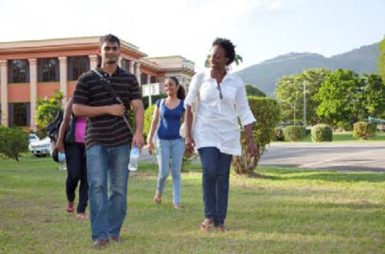

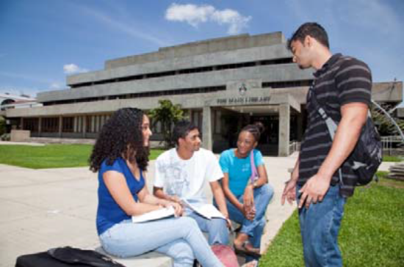

THE DEPARTMENT OF CIVIL AND ENVIRONMENTAL ENGINEERING

The St. Augustine Campus offers degree programmes through seven Faculties each headed by a Dean. The Faculties are: Medicine, Engineering, Science & Technology, Food & Agriculture, Social Sciences, Humanities & Education and Law. The Faculty of Engineering is comprised of five Departments, namely: The Department of Chemical Engineering, the Department of Civil & Environmental Engineering, the Department of Electrical & Computer Engineering, the Department of Geomatics Engineering & Land Management and the Department of Mechanical & Manufacturing Engineering.

The Department of Civil and Environmental Engineering (hereafter referred to as the Department), celebrated its 50th Anniversary in 2011. It has come a long way from a modest beginning, with less than 10 students, in 1961.Comparatively, at present there are approximately 300 students enrolled in different levels of its 3-year BSc (Honours) degree programme. Moreover, approximately 60 students are currently pursuing M.Sc./Diploma in Construction Engineering & Management, Coastal Engineering & Management, Environmental Engineering, Water & Wastewater Services Management, Civil Engineering and Civil with Environmental Engineering. In addition, six students are enrolled in MPhil/PhD programmes.

Over the years, the Department has produced over 1,000 graduates in Civil (and recently in Civil & Environmental Engineering), who are responsible for the design, construction management and maintenance of infrastructure in the Caribbean region. Another noteworthy achievement has been the continuous accreditation of its BSc (Honours) – and since 2005 its MSc programmes in Civil and in Civil & Environmental – since its inception by the Engineering Council in the United Kingdom. Further, the Department has a strong tradition of participation by the industry in the delivery and assessment of its academic programmes. Furthermore, the current academic staff has come from Britain, India, Tanzania, and the Caribbean region, and have rich and diverse academic and professional backgrounds. For example, 15 out of 18 academic staff has higher degrees (M.Sc. and /or PhD) from overseas (Canada, India, Russia, UK and USA), and four are Fellows or Members of the Institution of Civil Engineers in London, UK.

Programme Offering

The Department offers programme of studies leading to:

Undergraduate:
- The B.Sc. Civil Engineering
- The B.Sc. Civil with Environmental Engineering

Postgraduate:
- M.Sc. Civil Engineering
- M.Sc. Civil with Environmental Engineering
- M.Sc. Coastal Engineering and Management
- PGDip. Coastal Engineering and Management
- M.Sc. Construction Engineering and
Management
- M.Sc. Environmental Engineering
- M.Sc. Water and Wastewater Services
Management
- PG/Dip. Water and Wastewater Services
Management
- MPhil/PhD Civil Engineering
- MPhil/PhD Construction Engineering

CURRENT MEMBERS OF ACADEMIC STAFF

Phelps, Harry, Professor, Emeritis | CMT, BSc (Wales), PhD (Manch), DIC, FICE, CEng, FAPETT
Banerjee, Goutam, Professor | BE (Civil, BE College, Shibpur); M.TECH  (Env. Engg., IITKGP);  PH. D (Civil Engg., IITKGP-self-guided)
Shirvastava, Gyan, Professor | BTech, MTech (IIT), DIC, MSc (Lond), PhD  (UWI), CEng, MICE
Charles, Raymond, Sen. Lecturer & Head | BSc, MPhil (UWI), MAPETT, FIAT, FICE,  REng
Banerjee, Kailas Sekhar, Lecturer | BSc, MSc (India), Ph.D
Clarke, Richard, Lecturer | BSc, MPhil, PhD (UWI), MIFS, CQE, REng
Cooper, Vincent, Lecturer | BSc (UWI), MEng (McGill), MASc  (Nova Scotia), PhD (McGill
Khan-Kernahan, Ian, Lecturer | BSc, MSc (Maths) (Lond), BSc, PhD (UWI),  MAPETT
Martin, Hector, Lecturer | BSc, MSc (UWI)
Mwasha, Abrahams | BSc, MSc (Kharkov), PhD (Wolverhampton)
Narinesingh, Pramenath, Lecturer | BSc (UWI), MSc (Delft), PhD (Delaware)
Gay, Derek, Lecturer | BSc (Eng) (UWI), DIC, MSc (Lond), PhD  (Texas), MAPETT
O’Brien-Delpesh, Charmaine, Lecturer | BSc, MSc (Waterloo)
Peters, Everson, Lecturer | BSc (UWI), MSc (Guelph), PhD  (New Zealand)
Villarroel-Lamb, Deborah, Lecturer | BSc (Eng) PhD(UWI)
Raymond, Mark, Lecturer | A Architectural Association School of  Architecture, MTTIA, O ATT, RIBA, ARB  B
Williams, Rupert, Lecturer | BSc (Eng.) (UWI), MEng (Br. Col.), PhD  (Miami)
Wilson, William | BSc (Guyana), MSc, DIC, PhD (London)
Ellis, Leighton | B.A. Hons., Dip. Ed., Distinction, UWI

Duties of Appointee:

The appointee will be attached to the Department and will report to its Head. The appointee will be expected to provide teaching, research and supervisory support in the undergraduate and post graduate programmes within the Department and such duties will be allocated by the Head of Department.

REMUNERATION PACKAGE

ANNUAL SALARY RANGE:
(US$1.00 = TT$6.25)

Senior Lecturer:

Minimum: TT$340,164.00 per annum
Maximum: TT$421,704.00 per annum

Lecturer:

Minimum: TT$239,544 per annum
Maximum: TT$333,456 per annum

BENEFITS:

- Special allowance of 6% of basic salary;
- Transportation Allowance of TT$3,250 per month;
- Up to five economy class passages plus baggage allowance of US$3,000.00 (TT$ equivalent) on appointment and normal termination;
- Unfurnished accommodation at 10% or furnished at 12½% of basic salary, or housing allowance of 20% of basic salary to staff making own housing arrangements;
- UWI contribution of equivalent of 10% of basic salary to Superannuation Scheme;
- Annual Study and Travel Grant (available after first year of service); -TT$20,717.00 per annum
- Institutional Visit Allowance – TT$ 7,200.00 per annum
- Book Grant – TT$6,000 per annum
- Contributory Health Insurance – 50%
- Group Life insurance Scheme

The Registry
St. Augustine
2017 June 22
/en

