
Volume 1. No. 1. April 2007

“A Gift from God”: Gender and the Feminist Ethnography of Water in Three Trinidadian Communities

Diana Fox, Heidi Savery, Ron Dalton

Abstract
Water is abundant in Trinidad, but only 14% of the population receives piped water to their homes seven days a week for 24 hours a day. The rest struggle to meet their water needs through a number of strategies ranging from simple rainwater collection tanks to locally engineered dams. This article has three objectives: 1) to report on a preliminary ethnographic study of water acquisition and management processes in three Trinidadian communities, examining the impact of gender ideologies as a key component in the decisions, work patterns, values and meanings associated with water; 2) to situate the study within the larger research project, ‘Women, Gender and Water’ organized by the Centre for Gender and Development Studies, UWI St. Augustine; 3) to explore the nexus among international, national and local water discourses examining overlap and divergences among UN Millennium Development Goals (MDGs), national water policy and local processes at the village level. Conclusions point to the centrality of gender analysis to any policy recommendations that seek to improve the water problem in Trinidad and Tobago, arguing that effective public policy is more likely to result if policymakers understand the gendered, cultural meanings of people’s behaviour.

Introduction
“As I does always say, I find it does be fair to the nation, that all of us have to buy water, because now, if you doing something very important or yuh doh have a cent, how it is yuh will get a glass of water?” (Interview with man in Mt. D’Or, Eastern Main Road 6/13/05)

“If we doesn’t have water here and we should leave from this area and go by a stand-pipe in another area that has water, we’s get in real trouble because the villagers and the people in that area does want to run you from by the stand-pipe and ting” (Interview with woman in Jones Village, Barrackpore, 6/13/05).

“Women control water. Because I for one doesn’t like to see water runnin’ and pipes runnin’. I doesn’t like to see water wasted. I tell my children not to waste, to cherish” (Interview with housewife, Plum Road community, Manzanilla, 5/26/05).

This paper is a reflective analysis of preliminary ethnographic research conducted in three Trinidadian communities from April to June 2005. One goal is to contribute to a discussion of the intersectional relationship between water management and gender constructs in the Trinidadian context. Trinidad’s mismanagement of water issues at the level of the nation-state is felt deeply in communities throughout the island, producing local, gendered discourses of water development in response to an ever-growing urgency surrounding reliable, equitable distribution and access to potable water. Such mismanagement is connected to the priorities of the state, which have inadequately addressed the development of the island’s water infrastructure since the oil boom of the 1970s, the ensuing recession of the 1980s, and subsequent economic restructuring through World Bank/IMF neoliberal structural adjustment policies. In the 1990s, the development of water resources was subsumed within discussions about privatization oriented around profit—to the ongoing neglect of local concerns (Mycoo, 2005). As such, another goal of this article is to elucidate the articulation of local water issues as they pertain to gender, by locating them within national and international development discourses. We begin at the community level with an arrival story…

…The red striped, white maxi-taxi van slowed to a stop on the Eastern Main Road at the foot of Mt. D’Or. We paid the driver and stepped out into the bright, late afternoon sunshine. “We can take a route taxi up the hill or walk,” my guide said. As a graduate student from Holland, doing her doctoral research with the Centre for Gender and Development Studies (CGDS) at the St. Augustine campus of UWI, Hebe Verrest had already conducted substantial research with residents of Mt. D’Or. I was fortunate that a few days before heading back to the Netherlands, she was able to take me along on one of her last visits, to show me around and introduce me to people she had worked with. I had arrived a month earlier on a Fulbright fellowship—a cultural anthropologist with substantial fieldwork experience in Jamaica—but this was my first trip to Trinidad, and my first foray into formal fieldwork with a specific project. With my background also in environmental studies and gender studies, the director of CGDS and I had earlier decided that I would contribute to the project known as ‘Women, Water and Gender’. Since Hebe had been doing research on small home businesses in the community for a number of years, and had established a solid rapport, she was well-placed to introduce me to community members to begin my own fieldwork.

Key among my first introductions was “Dorris”, an organizer of women and widely respected in the community, whom I hoped would assist me, and my American research assistants Heidi Savery, Ron Dalton and Wendi Murray, in gathering together groups of women, men and children to discuss emic views of water management. We sought to understand the meanings and values attributed to water both in households and in the public domain of community spaces, such as springs, collective water storage tanks, and the open drains/gutters lining the roadside. Central to this inquiry was the role of gender in shaping, 1) a division of labour around water usage; 2) decision-making power regarding water regulation and distribution; 3) attitudes, ideals and perhaps even the metaphysical/spiritual significance of water linked to religious beliefs; and finally 4) stories or folklore surrounding water. The quotations at the head of this article, acquired from interviews in the three communities of research, identify some of the ways in which villagers interpreted these topics. The emotional import penetrating just these three comments indicates the centrality of issues of fairness and morality in the control of water, socialization of children, and inter- and intra-community tensions surrounding water usage. They also offer an initial insight into the contributions of an ethnographic methodology toward understanding the layered complexity of the above topics.

I anticipated a hot, sweaty climb up Mt. D’Or, but “walking is fine” I said to Hebe, knowing that going on foot afforded me more intimate observations of my first entry into the community. Moreover, being seen walking in this future fieldwork site was a crucial, and literal, first step in building rapport with the residents. We began the steep climb, which I would repeat numerous times over the next few months, either on my own or accompanied by Heidi, Wendi, and Ron, and also equally numerous, by my 3 ½-year-old daughter. A similar process occurred over the next few months in the communities of Plum Road and Jones Village. The villages had been visited by other researchers associated with a project already underway. This initial ethnographic component was only a small part. Contact persons were already established and an appreciation of each community’s struggles to obtain water acquired. Our research therefore became an extension of earlier work. Moreover, both Jones Village and Plum Road are rural communities, Plum Road located in the eastern part of the island, and Jones Village in the southwest. The addition of Mt. D’Or meant the inclusion of a peri-urban community in the highly populated northwest corridor. In addition to representing different geographic regions and population densities, the ethnic make-up of the communities differed. Plum Road is a mixed Afro-Trini and Indo-Trini (East Indian) community; Mt. D’Or is predominantly Afro-Trini with a small cluster of East Indian squatters, and Jones Village is an East Indian community. These ethnic variations were regarded as potentially significant, offering insight into different religious beliefs surrounding water and different political alliances, based on Trinidad’s two-party, ethnically based parliamentary democracy. Thus, in addition to providing continuity with previously conducted research, the communities were selected for their geographic and demographic attributes.

The established project ‘Women, Gaunter and Water’ is ongoing and involves a multidisciplinary team of researchers at UWI as well as outside consultants, and is coordinated by the CGDS. Its central aim is “to apply gender analysis to the sustainable management of human and natural resources to ensure adequate and equitable access to safe water for all users and uses” in Trinidad and Tobago (CGDS, “Research Project: Women, Gender and Water,” p.1).

In order to achieve the two goals outlined above—1) the intersection of water management and gender dynamics in the three communities; and 2) the articulation of local with national and international discourses of water development policies—this article reports on the insights gained through a brief, but productive period of ethnographic research. We begin with a concise history of Trinidad’s national water policies and their connection to UN Millennium Development Goals (MDGs), which are currently the most significant globally, defined objectives driving national water policies. Next, we present an overview of the feminist ethnographic methodology employed in the data-gathering process that structured our focus on the role of gender with respect to water. A discussion of findings ensues, concluding with some reflections on the direction of future ethnographic research for the CGDS study.

Trinidad on the global stage

Within the next 20 years freshwater will become the most important strategic resource, essential for sustaining life and achieving sustainable development. Its control will be a source of power and the key to economic development, and it will be one of the root causes of socio-political stress (UN Interagency Task Force on Gender and Water, 4: 2005).

Trinidadians do not need UN experts to inform them of the socio-political stresses surrounding water. Reliable access to clean water has taken centre stage on numerous occasions in the island’s history since the colonial period when the public began to rally their leaders for an improved water supply. Schneiderman and Reddock state, for example:

The Water Riots of 1903 happened because Trinidadians, especially the poor and women, feared imminent government infringement of their rights to a basic necessity of life. More than one hundred years later, in the year designated by the United Nations as the International Year of Freshwater, Trinidadians in general and women in particular, still had reason to riot regarding their water supply (2004:180).

After independence from Britain in 1962, Trinidad embraced international trends, which called for urban industrialization and modernization of infrastructure. The Water and Sewage Authority (WASA), currently the country’s largest public utility, was established in 1965 to manage water resources and growing demand during this period of rapid development. In the 1970s, following the World Bank’s agenda to meet “basic human needs” through expansion of the public sector, the T&T government, aided substantially by oil revenues, expanded its social services. These included increased subsidization of utilities such as water supply. It was at this time as well that WASA applied to the Inter-American Development Bank for funds to build the country’s largest water dam (Mycoo, 2005). However, in the 1980s, the burden of public spending initiated major economic restructuring. Michelle Mycoo contends, “if the 1970s can be described as a period of increased public sector activity in pursuit of more equitable development, the early 1980s witnessed a reemergence of free market economics as part of an ever-changing development orthodoxy” (2005: 515).

These shifts in government approaches, informed by international development agendas, resonate locally. The belief, for example, that governmental appropriation over the use of natural resources, including both water and oil is unjust, is a theme that pervaded our interviews. One man in the village of Plum Road for instance expressed his anger that so much money was made off the oil—which, he asserted, comes from the land that supposedly belongs to all Trinis—but the people see no return. He was particularly perturbed by the prospect of water privatization, stating that it “is a waste of time; its only purpose is for someone to make money. We are a rich country and the people do not receive any benefits.” He, along with others, contended that economic development policies have largely not considered the pressing needs of the majority.

The current global movement to privatize water focuses on large profits through high prices, which ultimately denies the poor their expressed right to the most necessary substance for life, what many people described to us as “a gift from God”. Our case study material does not substantiate the underlying premise of privatization, which views the public sector as inefficient and under-resourced while the private sector is capable of bringing greater efficiency through competition in water provisioning (Mycoo, 2005, see also Elmendorf and Isely, 1983). Instead, Trinidad’s historical flirtation with water privatization combined with its current, persistent inefficiencies leads local social actors to feel isolated and alienated from the very same politics that claim to protect them and improve their standard of living.

On the international stage, political strategies around water have been proffered most compellingly through the UN’s Millennium Development Goals, specifically goal number 7, to “ensure environmental sustainability”. Three targets are associated with this goal including: (1) to integrate the principles of sustainable development into country policies and programs and reverse loss of environmental resources; (2) to reduce by half the proportion of people without sustainable access to safe drinking water; and (3) to achieve significant improvement in lives of at least 100 million slum dwellers, by 2020.

Achieving these targets and other MDGs rests on intergovernmental cooperation and the involvement of a wide array of actors including academics, NGOs, international donors and of course UN agencies. The effort is a global one, “in the service of a great global cause…a microcosm of a larger truth: achieving the Millennium Development Goals will require a global partnership suitable for an interconnected world. The world truly shares a common fate (www.millenniumproject.org/reports)” Yet, as Taylor and Buttel contend (2006), global environmental discourse has emphasized peoples’ common interests to the exclusion of “differentiated social groups and nations having different interests in causing and alleviating environmental problems” (2006: 408). The decisions rendered by the government of Trinidad and Tobago engendering community disaffection are linked to mandates derived from the global discourse, emphasizing commonalities over important differences. According to Taylor and Buttel this discourse:

…privileges two allied views of politics—the moral and the technocratic…emphasizing remedial environmental efforts…In technocratic formulations, objective, scientific and (typically) quantitative analyses are employed to identify the policies that society…heeds in order to restore order or ensure its sustainability or survival—policies to which individuals, citizens and countries would then submit…Moral formations reject coercion and rely on each individual making the change needed to maintain valued social or natural qualities of life. Yet, in many senses the moral and technocratic are allied. The solutions appeal to common, differentiated interests as a corrective to corrupt, self-servicing, naïve or scientifically ignorant governance…In short, the global society needs management to achieve control (ibid: 408, 411, emphasis added).

An argument can be made that the government of Trinidad and Tobago, with respect to its water policies, has followed this global society model since independence, to the neglect of varied, localized, gendered perspectives. The model continues today with pursuit of the MDGs, embracing, rather critically it appears, the contradictory features of this international discourse. In so doing, the government of Trinidad and Tobago has limited its capacity to address the problems of distribution, delivery efficiency, and sustainable use in ways that encompass the complexities of distinct communities in their particular environmental settings.

In order to clarify the shortcomings of Trinidad’s present water policy, it is useful to explore in greater depth the contradictions pervading the MDGs, and the UN’s conceptualization of shared requirements for managing water resources. In 2003 the Johannesburg Implementation Plan declared 2005-2015 the International Decade for Action, outlining, among others, three agendas: 1) community control of water planning where women are integrated into central roles from village level water boards to Water Ministers; 2) policies that are both sustainable and equitable, so that water distribution is not interrupted by class/race/ethnic/gender discrimination; and 3) private sector water development where there is competition for corporate control over water facilities—albeit with an emphasis on corporate accountability. While the first two agendas are closely linked, the third is starkly contradictory. According to the Water for the People Network (WPN),

Privatization grossly violates the people’s human right to water because it distorts the provision of water supply and sanitation as a basic service and regards water just like any other commodity that corporations can exploit and profit from. This distortion results in prohibitive user fees and other charges that poor households could not afford (Independent Media Centre (IMC) 9/14/2005).

Moreover, a report entitled ‘Gender, Water and Sanitation’ prepared by the Interagency Task Force on Gender and Water Sub-program of the UN Water and Interagency Network on Women and Gender explains that the tension between the right to water and the privatization of water services mainly affects women and girls as primary water collectors, “when corporate profit motives supersede attention to human needs and rights” (2005: 10). Ironically, a UN agency task force involved in the pursuit of the MDGs is itself critical of one of the central components of the Water for Life Decade for Action.

Yet, rather than being atypical or a mere incongruent oversight, these contrasting agendas, according to the WPN, are part and parcel of “the promotion of the MDGs of the same neoliberal policies such as privatization that have, in the first place, aggravated chronic global poverty and severe inequity” (IMC 9/14/2005). Christa Wichteric, author of The Globalized Woman: Reports from a Future of Inequality, expresses a similar view. She writes, “the global age…is a contradictory and desynchronized process that pulls in different directions at once…women are integrated into the economy and the world market, but at the same time are immediately re-marginalized (1998: x). Wichteric further explains that neoliberal economic policies collide with “the household economy and reproduction that are still the centre of life for most women” (ibid: xi), including women in Trinidad.

The inclusion of women as a pivotal factor of the Decade for Action is based on recognition of their knowledge of water resources and community-level contributions to local water projects. Around the world, women are primarily involved in cleaning, sanitation, and family health, as well as children’s education around water access and conservation. As a result, women are usually highly knowledgeable about water sources, their quality, reliability, and any restrictions to their use. Thus it is reasoned, women’s involvement at multiple levels in the design of water distribution and management plans will ease their access to water by producing an efficient, regular supply close to home. This in turn will affect women by generating greater self-esteem, reducing their exposure to the threat of violence and health hazards, and expand time for education, childcare, and other activities, all of which improve women’s life conditions. Moreover, according to the report by the UN Interagency Task Force on Gender and Water, where the above contributions of women are outlined, the MDGs are closely related, so that pursuit of MDG No. 7, “to ensure environmental sustainability,” is closely linked to MDG No. 3, “to promote gender equality and empower women” (http://www..org/millenniumgoals/).

Let us now examine how the MDGs have been incorporated into the water policies of the government of Trinidad and Tobago (including WASA). Importantly, a woman, the Honourable Pennelope Beckles, currently heads the Ministry of Public Utilities and Environment, and women head other ministerial positions as well—perhaps reflecting a small but growing worldwide trend. Their appointments contain the potential to precipitate gender-oriented changes in WASA. Nonetheless, gender is presently not explicitly mainstreamed into WASA’s national water development plans, in spite of the government’s proclaimed objective to meet the MDGs of water safety and environmental sustainability. In her presentation at the Fourth World Water forum in Mexico City in March 2006, Minister of Public Utilities and the Environment Penelope Beckles stated:

Trinidad and Tobago, a small developing state with a population estimated at 1.3 million, has implemented a program of action, which targets improvements in water supply and sanitation services, security of food supplies, protection of ecosystems, prudent management of water resources policy and legislative development and institutional reform and capacity building. This program of action flows out of a vision for developed country status by the year 2020. It incorporates a very broad and comprehensive strategy for development involving all sectors of our national landscape. Our vision for development is placed within the framework of the United Nations Millennium Development Goals (MDGs). The program of action relating to water sector issues is largely directed by Targets 1 and 2 of MDG No. 7 (3/22/06, p. 1, 2).

In her ensuing discussion of the institutional mechanisms to achieve these targets, there is no mention of gender equity.

A year earlier, during the thirteenth session of the UN Commission on Sustainable Development (CSD) in New York, Ms. Beckles stated the government’s position, identifying the authorization of a new wastewater treatment plant among other growth initiatives which would contribute to the achievement of MDG No. 7. These included: a) developing plans to integrate water, wastewater and integrated solid waste management; b) launching a national reforestation and watershed rehabilitation programme to improve the protection of freshwater sources; c) a community-based programme for the protection and enhancement of the environment; and d) the implementation of a US$200 million programme to improve the delivery of water (Grimes, 2005). Although Beckles highlighted community involvement, environmental sustainability and efficient delivery of water as part of the agenda, again gender equity was not explicitly discussed. It thus appears that the two allied views of politics highlighted by Taylor and Buttel, and the contradictory agendas of community empowerment and privatization, are critically cluttered together in Trinidad and Tobago’s water plans. Moreover, there is no mention of MDG No. 3 and its links to goal No. 7.

Additionally, in a search of WASA’s website, the terms ‘gender’ and ‘gender equity’ are also absent; nor are they incorporated into any discussions of future plans. Instead, CEO Errol Grimes reports in the company’s future plans, ‘Look into the Future’:

In our thrust forward, we will be considering ways to expand our partnership with the private sector and to collaborate more with our customers and the trade ions whom we recognise as key stakeholders. We want to expand our reach locally, regionally and globally and have already signed a mutual assistance agreement with the Public Utilities Board of Singapore, a company recognised as the world-class model in wastewater management and water recycling.

Moreover, in spite of WASA’s stated intentions to collaborate more with customers, there appears to be a rather complacent view of community water conditions, adopted both by the UN Interagency Task Force on Gender and Water and by the government of Trinidad and Tobago. As recently as 2005, the Task Force reported:

In Trinidad and Tobago, most of the community water projects have been run by women, and these projects have been working very well, according to the Water Development Division of the Ministry of Food Production and Maritime Resources” (Background Paper No. 2 DESA/DSD/2005/2, emphasis added).

The problems of such a superficial summary are many. The statement is hardly expressive of inequalities at the community level, manifested in a traditional gender division of labour where women assume inordinate work burdens. Nor does it adequately describe the varying experiences of most communities with their water projects, as our study has clarified. The statement ignores fluctuations in successes, recent changes in local initiatives which have yet to be played out, and communities where such organizing is nonexistent. The three communities included in this preliminary ethnographic study represent examples of each of these constraints, and will be elaborated below in sections devoted to each. It is clear from the above discussion that comparative, multi-site ethnography of Trinidadian communities is necessary to produce the kind of layered insights required to craft effective public policy, and to underscore glaring inconsistencies.

The CGDS study and Trinidad’s water distribution troubles

The contours of Trinidad’s water problem, community activism around it, and its solutions are all within the purviews of the CGDS project ‘Women, Gender and Water’. Thus, to pursue the second goal of this article, to examine the intersectional relationship between water management and gender constructs in the Trinidadian context, the following segment offers a summary of Trinidad’s predicament with respect to water availability and distribution, drawing from the project’s first stage of geological and case study research (Schneiderman and Reddock 2004; Sirju-Charran 2004). Schneiderman and Reddock’s article “Water, women and community in Trinidad, West Indies” (2004) is devoted to an in-depth examination of the current water supply predicament, its historical antecedents and community efforts to meet their water supply needs. Some of their findings will be concisely reiterated here.

Trinidad does not have a shortage of water. Instead, its existing resources are poorly managed so that water deficits persist, aggravated by a five-month dry season, and rapid deforestation. The country obtains 31% of its potable water from tapping groundwater and 69% from surface water drawn from three reservoirs. Water use is distributed among domestic purposes (one-third); industrial purposes (one-fifth) and for irrigated agriculture (less than one-twentieth). Approximately 50% of the island’s water supply is accounted for:

Examples of accounted-for water losses include illegal connections, accounting procedure errors, reservoir seepage and leakage, reservoir overflow, leaks, theft and evaporation…the high percentage of accounted-for water in Trinidad and Tobago suggests problems with the water supply infrastructure and a lack of efficient management of WASA (ibid: 181).

As a result, even though most Trinidadian households are connected to pipe-borne water, supplies are regularly interrupted. In December 2005, according to Minister Beckles, “the level of the population receiving a 24/7 (interrupted) water supply...stood at 25%” (2006: 2). This represents a marked improvement from 2003, at which time only 14% of the population received an interrupted supply (Sirju-Charran, 2004: 4).

Still, because 75% of the population receives an interrupted supply, communities across the island have engaged a range of strategies to meet their water needs, but they do not do so easily or without significant costs, both economic and social. People are frustrated with “the loss of productive time spent carrying water; fear for the safety of people—especially women and children—who must fetch water late at night; and concern for children, elderly and disabled people who had to fetch water from a standpipe and transport it up a steep hill (ibid: 185).

Methodology: Feminist Ethnography

We adopted a feminist ethnographic analysis to deepen understanding of local configurations of larger gender patterns distilled in water management practices. We examined the ways in which behaviours surrounding the access, distribution and use of water both embed gender ideologies reinforced through the politico-economic policies of the nation-state and offer resistance to them. The application of feminist theory in research methodology earths these configurations. Listening to women’s perspectives, for example, and weighing their insights alongside those of men privileges “the images and meanings given…by social actors as they construct their worldviews and understand themselves as gendered individuals” (Barrow, 1998: 344). This acknowledgement takes the so-called objectivism of logical positivism to task, packing cultural interests and assumptions that infuse this system of inquiry. The supposition that value-free procedures guide research is erroneous—an insight that has stood at the centre of feminist epistemology for at least two decades. Yet, as Harding has clearly stated in her critique of masculinist science,

I am not proposing that humankind would benefit from renouncing attempts to describe, explain, and understand the regularities, underlying causal tendencies, and meanings of the natural and social worlds just because the sciences we have are androcentric. I am seeking an end to androcentrism, not to systematic inquiry (1986: 10).

Because the feminist ethnographic analysis we applied shares this supposition, it is not a detour but rather a pivotal component of this article’s thesis, to outline how systematic ethnography proceeds, guided by the tenets of feminist theory.

An initial insight is that systematic analysis itself is not devoid of social processes (ibid: 50). Social processes occur in the moment of doing research, not only as historical and cultural tropes impacting topics of study, such as gender and water. Structured procedures, for example, are frequently interrupted and redirected by anticipated events and insights, so that an unbroken, seamless operationalization of a conceptual process is exceedingly rare in ethnographic inquiry. The ‘system’ of ethnographic feminist methodology thereby incorporates flexibility so that recognition and subsequent inclusion of the foreseen and expected is regarded not as detractions from or errors in the process of inquiry, but rather as reflections of social processes embedded within inquiry.

A sudden downpour, for example, which occurred during the group interview with women in the community centre of Mt. D’Or battered the aluminium roof and drowned out all possibility of further discussion for its duration. The startling deluge occurred as we were discussing differences in water management practices during the rainy season, just commencing in Trinidad. The rain injected a moment of ironic humour. Standing in front of a semi-circle of women, we paused in our questioning, shrugging our shoulders in a “What can you do?” gesture, while many of the women held up their hands, gesturing to the outdoors and laughing as if nature herself and the prescient timing of the powers that be could be no better illustrator of the fact of full water storage tanks during this season. Instead of continuing with the impossible task of a soggy discussion, we switched the steps of the data collection process around, and began to pass out surveys, only returning to group discussion once the rains had ended.

Now, our conversations were influenced by the ideas that the women had introduced into the questionnaire. Since each of the researchers talked with individual women, helping those who had questions about the surveys, their responses to the group questions were more specific, informed by their answers to their individuated, household and family situations that they had just expounded on in the survey. Also, the feeling in the room had changed. It was more relaxed and intimate. When the group broke up, a few women stayed behind to talk to us, their demeanour less formal and open. Other examples of the ad hoc in the course of this research abound; some of their tales will be told as the story of this research project folds. Suffice to say, they are not aberrations, but part of the social process of ethnographic research, which feminist analysis embraces.

Implications for the present study

Equipped with this methodological toolkit, we developed an approach that built on many of the above insights. Rhoda Reddock, director of CGDS, assigned the three selected communities to us for the demographic and geographic reasons outlined at the start of this article, and because Plum Road and Jones Village were part of the initial component of the study. For consistency, the research team planned to be in each community for three days at minimum. During this time, and with the assistance of local community leaders and representatives, we organized residents into four study groups—men, women, households and schoolchildren. We held group discussions and administered individual surveys with separate groups of men and women to compare and contrast their perspectives regarding the value and meaning of water. We also elicited areas of distinction between the two, sharing when possible, the views of women with men and vice versa after they had supplied us with their initial responses. Sometimes this led to disagreements, other times concurrence. Following the assumptions of under-based research, we believed that separate groups of men and women would be more likely to speak openly and honestly about the other group. Women in particular would be less likely to be critical of men in their presence. In addition, we scheduled visits to local schools to talk with the children in the hopes of understanding what values and meanings they may have learned at home, at school and in the community.

Two or three researchers led group discussions on specific categories of ideas related to water as a necessity of life; as a source of stress and worry; as a pollutant and possible source of illness; as it is used in religious activities or rituals; as it is portrayed in folklore and myth; and as a commodity. We then stimulated discussion regarding ideas and beliefs on related topics with the conversation ideally taking on a life of its own. We recorded these sessions with permission and they were later transcribed by a research assistant at CGDS and added to project documentation. Additional researchers took extensive notes both of the discussion and on the general atmosphere, location, personal appearances, body language, expression, and group interaction. Each discussion group and session included photographs of participants, again with permission, one for the community and one for research purposes.

Next, we distributed survey questionnaires which included both multiple choice and open-ended questions allowing for more individualized data, and to acquire a large amount of information in a short period of time. Although surveys were also designed to collect demographic information on age, sex, religion and ethnicity, we inquired about beliefs and attitudes toward water in general and practices involving its acquisition and use. During further discussion and in working one on one, we were able to move beyond the limitations of short answer, yes/no and multiple-choice questions. The survey questionnaires for children were appropriately modified.

We also aimed to involve a sample of households via ‘door-to-door’ discussion and distribution of survey questionnaires to heads of households. Researchers worked in pairs, accompanied by a community representative whenever possible. This activity was planned for the evenings between the hours of three to six, canvassing the community in an attempt to draw a broad cross-section of household members. For the most part, we were able to follow the planned research methodology in each community with only a few minor adjustments.

Findings and the ethnographic process

With intermittent access to water in Trinidadian communities, many individuals as well as organized groups headed by women have assumed responsibility for their own water supply. By researching the strategies employed to obtain water by individuals and groups, their views about those strategies as well as feelings of powerlessness and frustration, the research revealed a variety of inequalities relating to under and power. These included the centrality of the gendered division of labour where women and children are the gatekeepers of household water conservation, related to the needs of household maintenance and social reproduction of prescribed gender roles. However, women’s roles, while critical in the limited context of water supply issues, are not in and of themselves transformative of women’s social status within their households and communities.

Although individual women are leaders of community organizations connected to water activism, and they are noted in their communities for their influence, their specific circumstances have not had a ripple effect in doing a traditional division of labour where the burden of household work pertaining to water falls on women. This observation reflects longstanding feminist insights that the historical role of individual women in positions of power and leadership is not sufficient to transform gender systems (see Langley and Fox 1998). Systemic inequalities must be accompanied by system-wide change to do the colliding and mutually reinforcing intersections between gender systems and politico-economic systems. Hence, the incorporation of MDG No. 3 into Trinidad and Tobago’s water agenda is critical.

The descriptive analyses of the communities below will highlight the gendered division of labour in relation to water availability and strategies for conservation. As earlier stated, the variations in communities with respect to their history and current involvement with WASA have shaped their differential access to water, and affect the nature of community water projects and their relative success. It will also become clear that perceptions and meaning of water are shaped in relation to labour itself, reproducing and informing persistent ideologies of gender inequality. At the same time, resistance to these ideologies are noted and recognized as potential points of intervention for the implementation of water policies that reflect the gender mainstreaming objectives of the international discourse in the Trinidadian context.

Mt. D’Or

Mt. D’Or is a peri-urban community about five kilometres east of Trinidad’s capital, Port of Spain. Of the communities visited during this study, Mt. D’Or has had the most experience with WASA, and it was the only community without a women’s group organized to pursue regular, efficient water availability. Public water is piped into the community, up fairly steep grades yet never reaching homes built at higher elevations due to the inadequacy of a pump, installed in the mid-1990s by WASA, located on a flat area in the centre of the community shops, below the government primary school. A constant flow of clean, fresh water from a local spring runs out of a rusted pipe from a condemned dam, lost to the gutters. WASA has done nothing to restore the dam destroyed in a flood over a decade ago, to its prior condition, and residents have not organized to bring this about. For this reason, and others, both men and women expressed enormous frustration toward WASA. One area of general concern, for instance, was a sense of fairness attributed to pricing regulations:

Woman 1: “Lots of people were complaining…like say two persons live in a house, they pay the same amount of water rate for the year as ten persons living in a house. Now that doesn’t work.”

Woman 2: “That’s what people were complaining about. Because if you pay like $500 for the year for water rate, right, and that person is just one person, he has to pay the same $500 as the ten persons that use water.”

In addition, because of arbitrary cut-offs, or the inability of the pump to transport water to hillside homes, community members, mostly women and children we learned, “tote” water for household cleaning. Climbing up the hill, carrying two or more large plastic canisters, they collect water from the rusted pipe emitting spring water for non-consumption, household use. Drinking water is collected and consumed treated from the spring above the pipe, or in household water collection tanks that fill up with rainwater draining from rooftops. In addition, people gather around the spring waiting for their turn to “shower” under it or to wash clothes. One day when we visited, two young men took turns soaping up and rinsing off under the pipe, while a couple waited their turn, perched together on a large rock, socializing and smoking. These apparent scenes of “leisure” do not undercut the explicit sense of outrage that is apparent in the above statements. They reflect an indignation about water-pricing policies that emerges out of a sense of injustice. Feelings of injustice, brought forth through the ethnographic method, are critical features of resistant ideologies, and signify potential openings for the inclusion of local perspectives in national policies. Such feelings emerged (in all communities) from women about their work burdens; from girls at the primary school when boys say that “washing wares and clothes is for girls”; and from men and women about pricing, water bills, irregular supply and other topics that will be enumerated in this section.

In addition to what we were told, we also observed the division of labour: we saw only women in Mt. D’Or washing clothes publicly—and watching children—in the open drains running alongside the road, through which the spring water passes, as it descends. One woman sat right in the middle of the drain in a section near to the spring, scrubbing a large pile of laundry, while keeping an eye on at least four children who were playing and splashing in the water around her. We saw two boys approach the rusty pipe with plastic buckets. “What are those for?” I (Diana Fox) asked. “For washing,” one replied. “Are you bringing them home?” DF continued. “Yes,” said another, “to my mother.” Men collect bucketsful from these drains to wash their cars or mix cement for household repairs. Initially and for a few hundred yards downward, the water looks clear and relatively clean—while further down near the Eastern Main Road the water is filthy, brown and filled with garbage.

Residents of Mt. D’Or work and shop both in the community and in surrounding towns; there is a marked shift downward in the income scale as one climbs higher—apparent in the size of homes and yards, types of cars parked in driveways, construction materials and upkeep of properties. Because Mt. D’Or was a bus ride away from our home and the university, we came here most frequently, establishing more of a presence than in either of the other two villages. Work here resembled the early phases of long-term, in-depth fieldwork with the establishment of rapport, building networks of informants, and generating insight into the nature of community life, so that the particular problem at hand could be couched within a broader context. This is crucial to anthropology’s notion of holism—the interconnectedness of peoples’ practices, beliefs, values and norms and the relationship among social, economic, subsistence and other patterns of daily life. In the remaining portion of this section, we convey a sense of these anthropological characteristics, along with the feminist ethnographic methodologies of both centring gender and acknowledging the impromptu.

Each time we walked up the hill to Mt. D’Or we were struck by the sense of community that engulfed us the higher we went: neighbours talking, women clasping hands, “Hello darling,” they said, waving and smiling; car horns honked as drivers waved at passers-by. As we approached the community centre, we passed a piece of land housing a church, a small grocery store and a few smaller shops, typical of the kinds of mini-markets one finds throughout Trinidad, a salesperson standing behind a high counter—sometimes encased behind a window of iron bars—selling drinks, bread, cell phone cards, cigarettes, Stag beer, and the like. Groups of men and one or two women clustered outside these shops ‘liming’; they nodded and waved as we passed by, making our way to the community centre where we would hold our group interviews.

All of us, white Americans, stood out in this predominantly Afro-Trini population, and were therefore questioned about our presence there. “We’re asking residents about water issues,” we invariably said, and, invariably, people had something to say, mostly about how water is wasted, seen dripping from pipes, and how, the farther up one goes into the hills, the more difficult it is to attain water. For the ethnographer, these ad hoc conversations become data, a gauge of the saliency of a topic. Water clearly was on people’s minds and on a few occasions passing conversations led to more in-depth ones, or offers to assist, as was the case of the man who worked for an oil company, whom we frequently passed. He explained that the community contains many springs, not just the one at the top of the road, as we had assumed.

As anthropologists immerse themselves in people’s daily lives, some individuals more than others will become interested in our presence and our work. One such man, a bamboo weaver crafting furniture, lamps, wine holders and other items out of bamboo fibres, took on this role. This young man was also connected to Hebe, the graduate student from the Netherlands, and, when she went home, transferred his attentions to us. I (Diana Fox) became the recipient of medical advice and frequent phone calls; in exchange for whatever prestige he acquired in being associated with us (on a few occasions both men and women called out to him, teasing him about his “American friends”). He organized the group of men whom we interviewed, took us on a tour of the main spring, introduced us to people along the way, and invited us to his home to show us his work-space. He also explained important insights into community life, such as the fact that it is small enough so that everyone knows who everyone else is, and, when children become adults, many of them remain, establishing their own households. For the ethnographer, this is all crucial information, in supplying a context and texture to community life. For the applied anthropologist, who seeks to use ethnographic data toward community-based projects that are deemed helpful by residents themselves, it provides valuable insights into potential areas of difficulty as well as ease.

On the evening of our group interview with men, for instance, we waited outside the community centre for an hour, and nobody arrived, except the community organizer, Dorris, who shook her head, and explained that this was typical of men; it’s hard to get them involved in community work, she said. Just then, the bamboo weaver passed by and joined the conversation. A big debate ensued about how to draw men together for the interview. At first he encouraged us to bring beer, but Dorris said this would give the wrong message—it wasn’t a party, and besides, we didn’t want to encourage drinking. We finally settled on pastries, and our bamboo weaver friend personally assured us that he would gather some men for us to talk to the next evening. True to his word, a small group of four did appear, and we had a very productive discussion. All were his friends, and one, a father with his young son, did not live in Mt. D’Or, but happened to be on a social visit.

In the middle of it, a woman arrived, a jocular, outspoken taxi driver (an unusual occupation for a woman). She had driven us up and down the hill quite a few times, and quickly inserted herself into the conversation. While our methodology had underscored the importance of separate male and female groups, the men welcomed this woman, perhaps because she straddled a liminal line, working in a male world. Tellingly, another woman, the girlfriend of one of the men in the group, had seated herself outside our circle; the group did not invite her in, and when we extended an invitation to her, she declined. Our taxi driver, however, engaged the men in a vigorous debate about the responsibilities of men and women in household water use and conservation:

Diana Fox: “What are the ways that men use water?”
Man 1: “Men use water to plant, use toilet facilities, bathe, washing clothes, cooking…”
DF: “Men use water for cooking and washing clothes? Is this true for men who live by themselves or men who live with women too?”
Man 1: “Women too. Some doh mind washing clothes…I have an uncle who wash all his clothes and he married over thirty years. And is not because his wife don’t want to do it—he just enjoy doing it.”
DF: “Do you think that women wash more than men do?”
Men: “Yes—of course” (all nodded).
Man 1: “Well, really and truly, women do more cleaning, you could say well, 65%.”
Man 2: “No, at least about 75% or 80% of women do the cleaning and you’ll find that 15-20% men clean the house…now and then.
Man 3: “Men will wash women clothes if their wife sick or something, right, they’ll wash the children…if she get back better…” (They all laugh).
Later in the conversation, Ron Dalton joins Diana in asking the questions.
RD: “Let’s say all the men and all the women had the same pile of money and they’re leading their lives like they do every day. Who is going to spend the most money on water?”
Man 1: “Men.”
Man 2: “Well they does really say women does shampoo they hair…”
Woman (taxi driver): [Shaking head, speaking loudly] Women are more concerned than men. It come like going to the market. We will walk all around to save a five cents and a man will say that’s enough.”
DF: “So even if women use water more than men, then women still will not pay—(cut off)
Woman: “Men waste water. I know big men who go by the pipe and just have this pipe running and running and they wouldn’t turn it off.”
[Later in the conversation]
DF: “Even though people have pipes in their houses, that doesn’t mean they’re getting water?”
Man 1: “That’s right. And if they get it, it will be once...plenty people do but not on an often basis. People living on top of the hill, they will get water once a week, sometimes they get it twice, sometimes they get water four times a week, sometimes two weeks they ain’t get none.”
Woman: “People still waste water. People don’t value water—they lookin’ to value water when it’s not there.”

This conversation underscores the differences in opinion that men and women have about who is responsible for conservation. Significantly, the sole woman participant links women’s protection of water resources to other household conservation roles—food purchases. But she also emphasizes the extra burden of work that this concern entails, “We will walk around to save five cents…” Additionally, when Man 1 discusses the irregularity of obtaining pipe-borne water, implicit is the understanding that women and children will be toting water to compensate for this lack. Thus, his frustration with dry pipes is shared, but the work burden is not.

Another problem is the reliability of water distribution from the WASA ‘water truck’ delivered to households when piped water is cut off by WASA itself (interview, Mt. D’Or, 5/19/05). Calling WASA to report a problem doesn’t ensure a speedy delivery, though, and while residents who are not hooked up to pipes can also receive water, they must pay a fee. Those who already have pipe hook-ups get billed for this delivery in their regular water bill—something which many in all communities expressed as fair since they should have received water anyway.

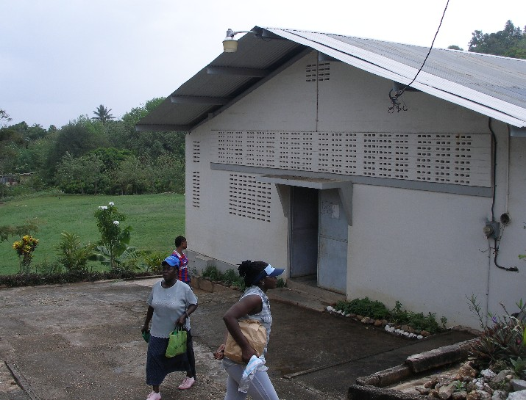
Figure 1: Mt. D’Or Community Centre All author photos 2005

Past the shops, one encounters the community centre, a long, rectangular, white building where we held our group discussions. Behind it is a large green space easily the size of a few American football fields, where you can find a group of men playing football (as the rest of the world knows it). To the right, basketball courts contained people of all ages shooting ball.
In the distance, on a hill, sits the large, rod, concrete water storage tank, recently covered because mischievous children had hopped over the fence encasing the tank and dived in. A child had drowned, we learned. Back in the field, we noticed that vegetable crops lined its borders and we were told that people often ‘wet’ their plants with water previously collected for bathing or ‘washing wares’ (dishes). Walking farther up, we approached the Mt. D’Or Government Primary School, but not before passing the fenced-in water pump, which, notably, was leaking.

Mt. D’Or is a community with a wellspring of natural resources, and the community clearly would like to harness them more efficiently to supplement existing water supplies. We regularly heard comments about the tapped potential of the various springs, and people also bemoaned the loss of spring water to the gutters. At the same time, women told us that things are better now, with pipe-borne water, however irregular it is. They tell their children stories about waiting every morning in long lines at the standpipe. One of the researchers asked, “Is community spirit diminished now that you don’t wait together for water?” to which one woman responded that fights often broke out while waiting in line, and people’s sense of irritation undermined any sense of togetherness. The women said that they wanted their children to understand that however hard it is now, things are better, and since they got better, they can continue to improve. Here again is a sense of resistance against apathy, as women endow their children with a sense of social responsibility in seeking to live a dignified life by obtaining the most basic of necessities.

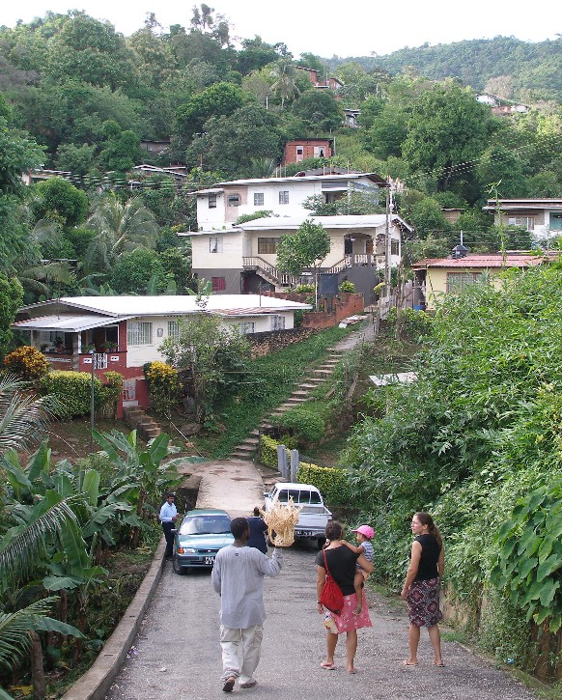
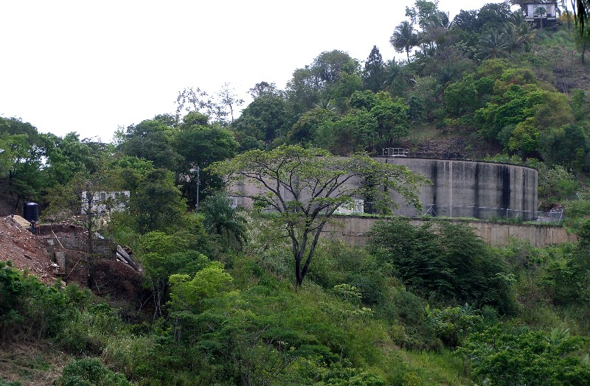
Fig.2 – Walking in the community Fig.3 – The Mt. D’Or Community Water Tank
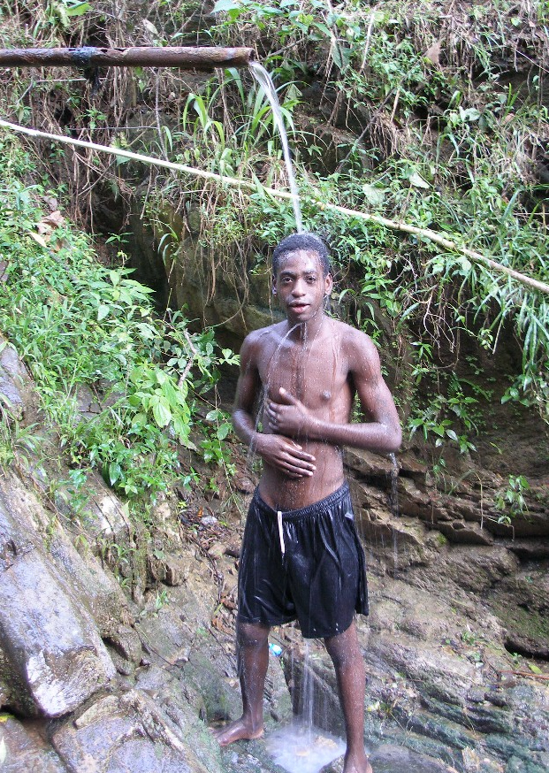
It is important not to overlook this fact: children are growing up with a sense of the value of civic involvement, and that even with relative improvement the understanding of what is rightfully theirs persists. In seeking “to generate civic responsibility for the stewardship of resources” as outlined in the MDGs, and reiterated in Pennelope Beckles’ address to the UN, the government of Trinidad and Tobago should be aware that this already exists in many communities. With more than a decade of experience with WASA, Mt. D’Or residents are in a position to evaluate the improvements in water access and also the problems associated with government-distributed pipe-borne water. Their knowledge should be tapped.

Fig.4 Young man showering with
water from a spring-fed rusted pipe

Plum Road

Based on its commitment to an agenda of ‘Water for All by 2000’, WASA has made its way into communities around the island, connecting some for the first time to a public water supply (Sirju-Charran et al, 2004). These new connections reinforce the obvious: communities are not encapsulated entities, so that even when local initiatives appear to be working well, outside forces—WASA as a case in point—may not agree. In the example of Plum Road, where women’s involvement has been instrumental in achieving improved conditions at the local level, their exclusion from top-level positions limits their ability to negotiate with WASA both within and across communities.
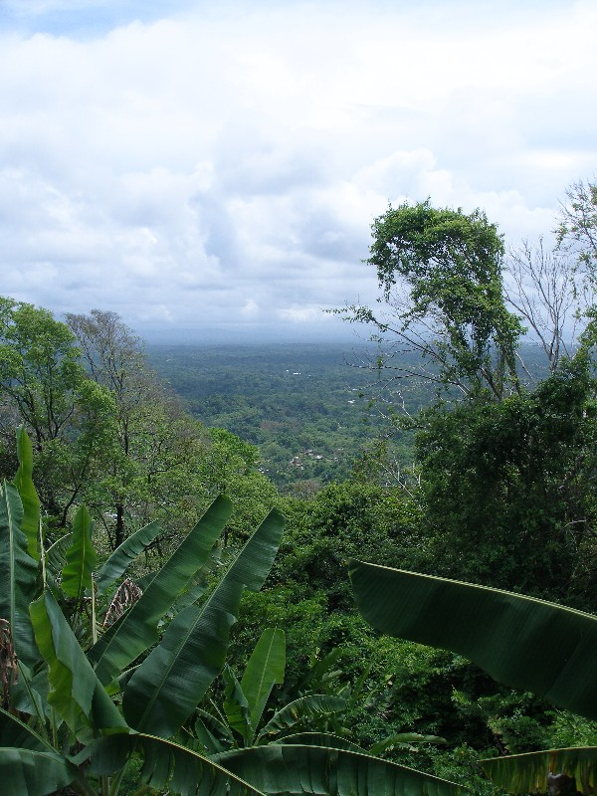
The village of Plum Road is a suburban community located near the eastern-most part of the Central Range, on the periphery of the town of Plum Mitan. Moderate to steep slopes are present with housing and shops situated primarily along or just off Plum Road. Most of the developed area is densely forested and a group of Howler monkeys still reside in the forest and can be heard loudly reporting approaching rainstorms. Several natural springs are present in or near the village and one particular spring has been dammed and used to supply water to the community.
Fig.5 View from Plum Road

As our study team learned, WASA connections have been made in Plum Road since 2004, because of requests made by an apparent majority of residents. However, no claims of belonging to that majority came from our interlocutors. Our host, Miss Rose, who has stood at the centre of community management initiatives in the maintenance of a local dam, said, regarding WASA’s entry into the community: “Enough people from the community wanted WASA—and everyone has a right to water—so WASA came.” Since not one person claimed to be part of the group agitating for government pipes, could WASA’s entry represent an example of centralization of authority in resource management asserting itself over residents’ own interests? Whether or not this is the case, there is certainly a disconnect between those who make decisions at the governmental level and those who experience their consequences.

Moreover, even if a majority had called in WASA, a local project is literally being cut off from central planning initiatives, undermining the work of those who had previously empowered themselves. To understand the current state of affairs it is important to understand the community mobilization around water that has been in place for more than five decades. Miss Rose explained to us what she had already described to other CGDS researchers:

“…in the 1950s, with help from Trinidad’s health authority, villagers constructed a dam downstream from a spring in the village and laid pipes to distribute water from the resulting reservoir. Prior to that, without pipe-borne water, adults and children fetched water from the spring-fed stream in the village” (ibid).

Since then, the community has survived on their labours, collecting spring water from three strategically placed standpipes around the village, and from the home of Mr. Rajbansee, Miss Rose’s father, who had led the initiative. Miss Rose, now 69, was just a child at the time, and she recounted to us, as she had to previous CGDS researchers, the pride she felt in her father and the impetus she gained to maintain the project as an adult. However, as the population has grown, Miss Rose explained, the supply doesn’t meet everyone’s needs. As a result, people apparently pressed WASA to connect them to the municipal supply.

When we arrived in Plum Road, this process of centralized disempowerment was underway. People relayed to us a sense of apprehension about the future of the spring and the nature of their future relations with WASA. At the same time, they were not complacent, and a number of individuals emphasized their intention to save their dam. Just as in Mt. D’Or, residents are not content to remain passive and let events sweep over them. As we walked throughout the village interviewing members of the community, a portrait emerged of a water system in transition. Rose Rajbansee still oversees regular cleaning of the dam, which she says is done mainly by men; however, as men clean, scrubbing the floor of the dam and the bore of the pipes with brushes and chlorine bleach, women gather around singing, encouraging the men in their work.

Today, Miss Rose is president of the Caribbean Network of Rural Women Producers and of the Trinidad and Tobago Federation of Women’s Institutes. She works with the Ministry of Social Development to improve women’s and children’s quality of life (Sirju-Charran 2004: 8). Over the course of our conversations, she expressed concern that the sense of collective interest and involvement in community life in general generated by the dam might decline, now that some residents were connected to WASA, and had no need to attend meetings. Ostensibly, these meetings were organized to discuss matters relating to the community water supply, but as Miss Rose said, when people get together, they discuss all matters of things important to individuals in the village.

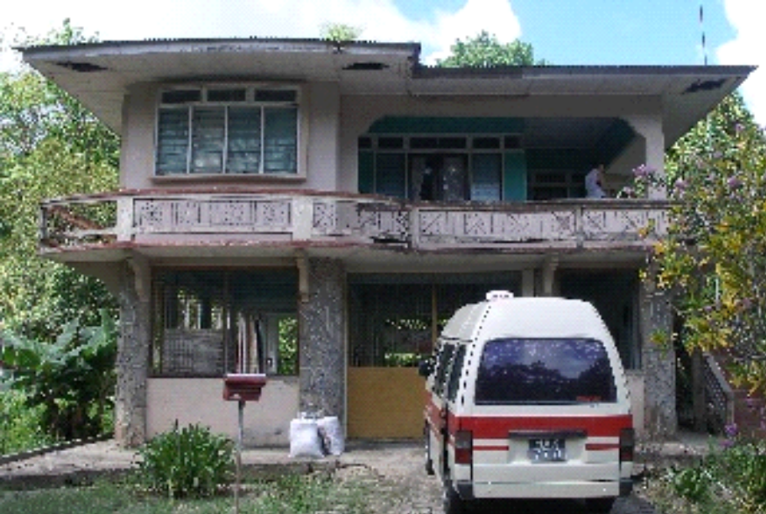
Others had their own misgivings. One elderly woman in her late 70s, who runs a small snack shop, said that one day she was connected to the dam and the next day she wasn’t. WASA had come to town, disconnected her dam pipe and connected her to
Fig. 6 Miss Rose’s house – researchers’ base

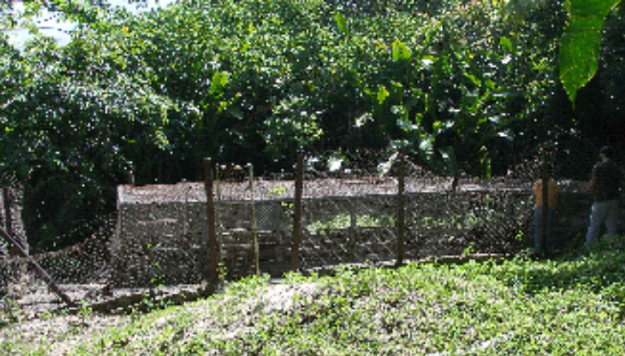
WASA. The elderly woman lives alone, has one water storage tank and now complains about the irregularity of her WASA connection. While dam water was cut off at night to “save the flow of water”, residents knew this and could store water accordingly. She is struggling to save money for another tank and asserted, “I intend to get a connection back to the dam. We are accustomed to dam water. I was fine with dam water.”

Fig.6 Water Reservoir

Other residents shared the sentiment, insisting that they would work to maintain the dam. We saw people who had WASA connections walking to the standpipe carrying dam water with empty cups to fill them for drinking. They informed us that they like the taste of dam water better, and they only used WASA water for cleaning. In another household, though, a brother and a sister living together said they preferred the taste of WASA water. Nonetheless, they were distressed that they apparently had had no say in WASA coming to town. In a third household, a mother came out of her home to fill her pot with spring water for cooking. She is connected to WASA also, but continues to use dam water as drinking water.

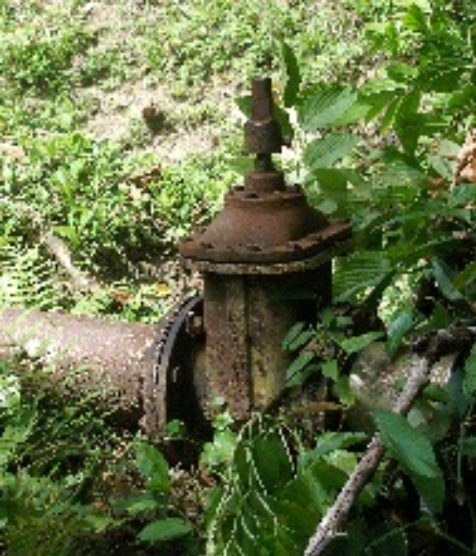
In Plum Road today, there are at least four forms of water access arrangements for households including: (1) WASA, dam and rainwater collection; (2) WASA and rainwater; (3) dam and rainwater; (4) and for at least one elderly resident, only rainwater collection. The great irony in this situation is that Trinidad’s ‘Water for All’ programme is supposed to reflect the gender equity principles of the UN Millennium Goals, yet here, one of the most defenceless members of the population—a widowed, elderly woman living alone—is rendered even more vulnerable through WASA’s intervention.

Fig.7 Reservoir Valve

Finally, there is a new anxiety in the village about WASA fees, and people find themselves in a range of predicaments with respect to bill payment. Some households that are not connected to WASA have received bills, while others connected for two years have yet to receive a bill, in spite of their inquiries. They are worried about the large fee they will owe and may not be able to pay when the bill finally comes. In addition, people are distressed that they are required to pay for full delivery even though water delivery is irregular. They are charged as if they are receiving water 24 hours a day, seven days a week.

Jones Village

In contrast to both Mt. D’Or and Plum Road residents, the Jones Village community exuded enormous enthusiasm toward WASA, having received the first household connection ever on the day of our visit. Jones Village is a rural community located on the flat, agricultural plains of southern Trinidad. There is very little topographical relief besides a few small hills scattered throughout the community. Due to the low elevation of the area, three of the rivers that flow through or near the village, the Cipero, the Oropouche and the Curamata are, fortunately, prone to flooding. The rivers are not clean: in addition to agricultural r-off, they serve as a convenient dump for a variety of waste materials discarded by auto garages, shopkeepers, residents and passers-by—a prominent concern that emerged in our interviews.

The women’s group we interviewed was confident in WASA’s ability to provide clean, safe water on a regular basis. It is perhaps because this community has survived through rainwater collection efforts alone, that the advent of pipes, however their potential irregularity, represents marked progress. As well, it is for this purpose that the Jones Village Women’s Group organized. Even in Mt. D’Or, in spite of significant tensions, people prefer WASA’s reliability to waiting for water in long lines at a standpipe. Moreover, like the Plum Road where there were apprehensions about community cohesion, this group was adamant that community spirit would remain intact, now that their organizing agenda was on the brink of being fulfilled. In the words of Neela Khan, the former community councillor:

“I don’t think that having water in the village is going to send the village apart. This is a community that is closely knitted and bound together—all men, women and children and this is the meeting place, so I do not think that having enough water is going to spread them apart. They can stay together for the future development of this community and that I respect them for and I highly commend them for that method.”

Khan praised the group and its leader, Patricia Samaroo, for their efforts in working to bring pipe-borne water to the village:

“I want to commend all of you who have worked real hard together with Patricia, who have been the backbone of your community in the sense of bringing water. Patricia will call me 24 hours a day, whatever day, whatever time, Patricia will call me with regards to water in your community and I’m very happy today that at least one person can turn on their pipe for now and see that water is running.”

Yet, while the community rejoiced about their success, they had other sources of stress—mainly regarding pollution of the waterways running through the village. One man present at the group interview described how dirty the river is today compared to years gone by:

“Long time I used to go to the river and dip a bucket and wash car and like when pipe water lock off—you cannot do that again…now you go to the river and take a dive and when you come back up, pampers all over yuh face and all nasty thing all over you—nobody wouldn’t want that.”

Additionally, disagreements emerged about the extent to which men are involved in domestic affairs and the importance of household work as paid labour, as this good- humoured but pointed exchange between one man and several women reveals:

Man: “Most of the time women are housewives…the majority of times women are housewives, so who is working? The men have to work to provide…”
Woman 1: “Ah, the bossman….”
Man: “…so I have to give from my pocket. Where the women work? [Laughter from women]. …women workin’, right, but they are housewives…they are not employed like myself…”
Woman 2: “But that is work.”
Man: “I have to provide…no, but even though it is my money…it is my money I have to spend.”
Woman 3: “I have to pay for mines myself.”
Man: “Yes, but in your case it’s different. You are a housewife and you’re employed but most of the time men have to pay for the water, because if you’re employed, yuh wife not working…”
Woman 4 (Neela Khan): “But who is the real boss?”
Man: “Me.”
N.K.: “OK. [Laughter from women] I just thought I would ask.
Man: “I have permission to say that, right?”
N.K.: “Once you have your wife’s permission.”

Despite this man’s assertions about his wage work as ‘real work’, he appears somewhat tenuous about his authority in the presence of this group of women. After the women laugh (in a mocking sort of way) when he asks, “Where the women work?” he quickly corrects his view that housework is not work by saying: “Women workin’, right” although he immediately reduces its value by reasserting “but they are housewives…they are not employed.” Of course, later in the conversation he admits that at least one woman in the group does work for wages. When Neela Khan asks him who is the boss in his household, he names himself—although his part-serious, part-humorous response acknowledges Khan’s status, when he asks, “I have permission to say that, right?”

This exchange, brief as it is, nonetheless signifies an important, ongoing shift in gender roles that is taking place. It reinforces the point, made earlier, that structural change in gender stratification requires multiple levels of coordination in order to break down entrenched inequalities. The dialogue reflects the friction of gender relations, an indication that they are in flux and stable both conceptually and in practice, and that the women and the defensive man are exposed to and influenced by wider ideas about domestic labour and women’s work. After all, this community exhibits the combination of both a woman’s group and a female political leader—not just a sole female leader—who together, and with the cooperation of like-minded men, have brought about a new condition in their water supply. A shift in the balance of power is underway.

In addition to domestic and monetary affairs affecting women’s and men’s views about water management, there is conflict regarding pollution and land use. It is a concern to all, but men and women negotiate it differently. Women are particularly disempowered when the sources of pollution come from societal arenas where they remain marginal. Yet village men too feel powerless to improve conditions when companies rather than individual, known persons are involved in the pollution. One man described how the oil company Petrotrin was contaminating the river from waste pond overflows. Community members use the pond, dug by Petrotrin itself on private land, during the dry season with permission from the landowner. As Schneiderman and Reddock learned earlier, “Women wash dishes and clothes in it. Children swim in it. Pond water is also collected and used to flush toilets…Children who swim in the pond have developed rashes” (2004: 184). In our 2005 interview, he also said that river water is dirtied by the “chicken pluck shops [that] dump in the night”.

In some instances, though, men have been confrontational with individual polluters in ways that women are not likely to be. The following example of an altercation that a Jones Village man had with another from neighbouring St. Mary’s, who was illegally dumping in a part of the river running through Jones Village, illustrates this quite clearly:

“About two months ago I was comin’ from work. I work shift—I finish around 2 o’clock that morning. I comin’ home and right between this junction here and the junction up there, it have a small bridge. I saw this pick-up there…park lights on and this guy dumping whole tires in the river. I stop. I say, ‘Good night, good night.’ Well, the three door lock and I come out from my car and I had my light on. I say, ‘Good night. Yuh getting’ problem?’ He say, ‘Nah, I alright…’ I say, ‘What yuh doin’? Breds, this is illegal dumpin’ man…this ent lookin’ nice on the village here…why yuh doh carry it in the dump instead and dump it? This is cloggin’ our waterways and it will have flooding.’ He say, ‘Well, who are you?’ I said, ‘That doesn’t matter—you are dumpin’ and it is illegal. What I’d like to ask you to do is to pick it back up, put it in your vehicle and get…I use some obscene, right…that time of the morning I coming home and you dumpin’ in my village…what you expect me to do? I use some obscene and he took it back up, load it in the van and I waited there then I went home…I have my cell phone with me…I was going to call the Barrackpore police, but he leave and went. I have his number. Anytime I see tires anywhere I will further his number to the police. I will do that.”
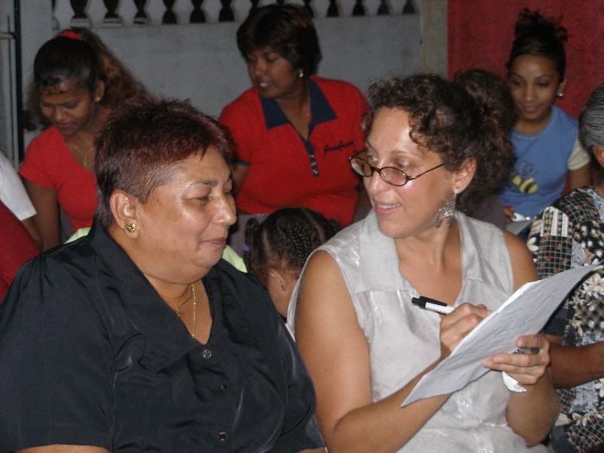

Fig.8 Dr Fox talking with a Jones Village community member

In Jones Village today, both men and women exhibit stress around water; however, they direct it differently. The distinct approaches to their concerns combined with their stratified uses express distinct meanings and values ascribed to water. The same can be said in all three of the study communities.

Summary: Water management and the gendered division of labour

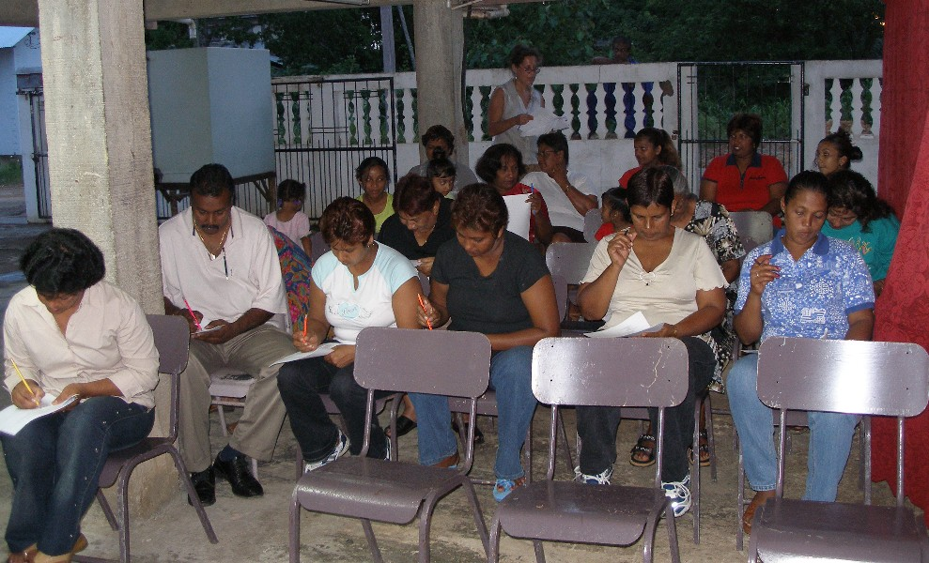
Even within a relatively brief time frame, our investigation of community water management through a gendered lens revealed that the sexual division of labour has a significant impact on women’s ability to control all aspects of community water usage. It is true that in both Jones Village and Plum Road women have played key roles in mobilizing their communities to change the sources of water access.
Fig.9. Women’s Community Group (with some men) completing surveys

Nonetheless, they still harbour a range of stresses, contradictions and feelings of disempowerment with respect to water management, all of them tied in some fashion to gender dynamics. We have seen that women’s general involvement in household responsibilities (‘washing wares’, ‘washing clothes’, ‘mopping out’, ‘wetting plants’ and ‘cooking meals’, for example) currently precludes any noteworthy impact they may have in other domains of water use where men’s labour is dominant, such as agriculture, construction and car washing. Women in all three communities stated that they urged men not to wastewater, “to cut off the pipe”, but their actual control seems restricted to domestic usage.

Men’s cars are their “babies”, one Mt. D’Or woman stated, and it a major concern to them. They continue to emphasize the importance of their paid labour over women’s paid household labour. Even when women work extensively with domestic water supplies and involve their communities in political agitation for water supply improvement, if men regard their own labour as a source of leverage for decision-making in and out of the home, then women remain structurally disempowered in spite of their activism, bearing the brunt of water acquisition and conservation measures. Moreover, they do so without formal political or economic profit, which makes you worry that their ongoing work will become increasingly marginalized, should WASA’s proposed privatization measures be implemented.

Conclusions and recommendations: Toward a gendered ethnography of water

Four clusters of commonalities emerged in the course of our research. The first is tension between communities. These emerge when people illegally dump garbage and waste in the water supplies of communities that are not their own; when people in one community have no water and come to another to use the standpipe, and the ones who live near the working standpipe try to “run them away”. Second, there is disagreement between men and women over responsibility for conservation of water. Women claim that they continually pressure men and children not to let the pipes run. Men generally agree that women bear the burden of responsibility for conservation in the home, but they assert that because it is mostly men who pay for water, they are the ones who are concerned about the cost. They seem to indicate that this is a more important arena of worry than any other, implicitly devaluing women’s concerns.

Third, in all three communities women tell their children stories about the recent past when times were harder, as an important part of their socialization, “to let them know what times were like and how they should be grateful” for greater ease today—in spite of whatever difficulties they still face. Women said it is important to tell children that if things have improved, they can continue to improve—without knowledge of the past there is no understanding of change and little sense of hopefulness for improvement.

Interestingly, we found little knowledge of Trinidad’s rich folklore about water. Our questions about Mama Dlo—part woman, part serpent—who lives in streams, protecting them and punishing contaminators, seems largely lost to the memory of older residents. Children in schools in all three communities returned our queries about Mama Dlo with blank looks. Even in Mt. D’Or where there had been a theatrical performance the previous year about the legendary character, and their teacher prompted them with reminders, children shrugged their shoulders and shook their heads. Tellingly, across the communities, children were familiar with a water song from the American television programme Sesame Street. In Mt. D’Or and Plum Road, they also referred to the story of John the Baptist and the ‘parting of the waters’ for Moses and the Hebrews to cross the Dead Sea.

Finally, we were able to receive any detailed responses to our questions about the religious or spiritual significance of water beyond some general commonalities. Everyone resolutely asserted that they “prayed for water” and many said that water is “a gift from god”, “the source of life” and “sacred”. However, few shared any detailed ritual behaviour aside from references to baptism and the Hindu lota ceremony, in which a copper bowl placed outside is filled with water in the morning over prayers. A few people in Catholic homes said that they sprinkled water around doorways and windows also in the morning as a way to bring peace to the home. It is likely that more in-depth knowledge of religious/spiritual significance of water can be gained through longer-term ethnographic research. The meaning and value of water, then, as it was conveyed to us, stems largely from social roles around collection and distribution, as well as stressors associated with limited supply.

With respect to children, further ethnographic research should consider developing alternative activities to make the most of interactions with children, since they are key representatives of gendered socialization in process. Children’s responses are likely to capture shifting gender role attitudes and to display a spectrum of responses indicating various degrees of gender role change in households and communities. Incorporating research objectives into a formalized lesson plan in the schools may be one approach to involve students, along with observing children’s use of water, and parental interaction with children in their daily environments.

An additional recommendation for follow-up ethnographic research includes cross-community collaboration and networking. With varying levels of experience with local initiatives and experiences with WASA, this type of collaboration could be extremely beneficial to communities. Plum Road’s experience with their dam could be instructive to Mt. D’Or residents, and Mt. D’Or’s experience with WASA could help prepare Jones Village residents for future interactions with WASA. Finally, WASA itself should be a subject of anthropological analysis to gain insider perspectives on citizens’ critiques. Since the 1970s, notably with Laura Naunder’s call for “studying up”, anthropologists have recognized the importance of turning the anthropological gaze toward cultures of power and affluence (Naunder, 1972). Certainly, WASA as a government bureaucracy qualifies as an institution of power in the eyes of the country’s citizens. Ironically, as the government of Trinidad and Tobago becomes increasingly entrenched in the international development apparatus through SAPs, it may regard itself as more of a victim of global economic processes rather than an active agent. A study of WASA and related ministries might research the following questions, for example: who are the 25% of Trinidad’s population receiving water 24/7, and what politics render their access possible? Why is it that female Cabinet Ministers are not centring gender in their planning, so that it is evident to all in public domains—websites, pamphlets, speeches, newspaper articles—that this is a central concern of water development initiatives? Because our findings indicate that gendered access and use are the strongest determinants of meaning at the local level, the multilayered, gendered power relationships at national and international levels, within which local conditions are couched, are critical subjects of study.

Water-related democracy will not be attained until all stakeholders participate in the political process. Moreover, water policies are more likely to be effective if policymakers understand the gendered, cultural meanings of people’s behaviour and the mutually reinforcing nexus among local, national and international levels of water management discourse. International commitments to link women’s status both to reliable access to water and to multi-level incorporation into decision-making power cannot be fully realized at the community level when national policies are only partially reflective of both local gendered realities and international gender equity objectives. The nation state as the intermediary between the two must understand and take seriously the ways in which its own actions reproduce two of the contradictions of international goals, stressing simultaneously community development and privatization, while neglecting the third goal, gender equity.

Additionally, the synergistic relationship among the international community, nation and communities identified by the UN as crucial for the success of the MDGs cannot occur if community actors are absent or marginally included in decision-making and planning processes. Since invitations may not be forthcoming, community agitation for inclusion is likely to be necessary. Understanding the organizations that NGOs are attempting to transform through ‘studying up’ is therefore critical. Moreover, communication and coalition building across communities, among those interested in local sustainable resource management, would help to build a grassroots base to pressure governmental action toward gender mainstreaming. Micro credit loans or grants to community groups and women in particular, through alliances with Private Voluntary Organizations (PVOs), the private sector, NGOs and the government is one possible way of linking the private sector to community organizing, and could facilitate such collaboration, helping to amass detailed information on community variations important for national policy initiatives (Elmendorf and Isley, 1983:197). The fact of these variations—affirmed within the bounds of this preliminary study—is as important as the “global common good” asserted in the international discourse, in developing gender-sensitive approaches to sustainable water management practices.

Bibliography

Barrow, Christine. “Anthropology, The Family and Women in the Caribbean.” In Patricia Mohammed and Catherine Shepherd, (eds). Gender in Caribbean Development. Mona (Jamaica): The University of the West Indies, 1988.
Beckles, Pennelope. “Development and Strengthening of National Mechanisms for the Monitoring of Water and The Establishment of Goals.” Round table discussion—Table 5. 3/22/06. Fourth World Water Forum, Mexico City, Mexico, 2006.
Centre for Gender and Development Studies. Research project: ‘Women, Gender and Water’. Published report, 2004.
Dirks, Nicholas B., Geoff Eley and Sherry B. Ortne (eds). Introduction in
Culture/Power/History: A Reader in Contemporary Social Theory. New Jersey: Princeton University, 1994.
Elmendorf, Maty L. and Raymond B. Isely. Public and Private Roles of Women in Water Supply and Sanitation Programs in Human Organization, 42, no.3 (1983).
Escobar, Arturo. 1999. Encountering Development: The Making and making of the Third World. Princeton, NJ: Princeton University Press.
Fox, Diana. An Ethnography of Four Non-governmental Development Organizations. Lewiston, NY: Edwin Mellen Press, 1998.
Grimes, Errol. “Environmental Sustainability in Trinidad and Tobago: Ensuring Safe Drinking Water and Sanitation,” UN Chronicle, http://www..org/Pubs/chronicle/2005/issue2/0205p23.html ( 2005).
Harding, Sandra. The Science Question in Feminism. Ithaca, NY: Cornell Univ. Press, 1986.
Hellum, Anne. “Towards a Human Rights Based Development Approach: The Case of Women in the Water Reform Process in Zimbabwe’ in Law, Social Justice & Global Development Journal (LGO): (2001):1
Klass, Morton. Singing with Sai Baba: The Politics of Revitalization in Trinidad. Prospect Heights, Illinois: Waveland Press, 1996.
Langley, Winston, E. and Vivian C. Fox (eds). Women’s Rights in the United States: A Documentary History. Westport, CT: Praeger Publishers, 1998.
Mycoo, Michelle. ‘Shifting Paradigms in Water Provisioning Policies: A Trinidad Case Study’ in Water Resources Development 21, no.3 (2005): 509-523.
Naunder, Laura. ‘Up the Anthropologist—Perspectives Gained from Studying Up’ in Dell Hymes (ed), Reinventing Anthropology. New York: Pantheon Books, 1972.
Oread Daily,. ‘Water for the People, Not for Profits’ on http://www.winymedia.org. Sept. 14, 2005.
Schneiderman, Jill S. and Rhoda Reddock. “Water, women and community in Trinidad, West Indies,” Natural Resources Forum 28 (2004): 179-188..
Sirju-Charran Grace, Jill Schneiderman and Rhoda Reddock.. ‘Sharing
Innovative Experiences: Safe Drinking Water—Innovative Experiences’. A
project of the Centre for Gender and Development Studies. The University of the
West Indies, St. Augustine, 2004.
Taylor, Peter J. and Frederick H. Buttel. “How Do We Know We Have Global Environmental Problems? Science and the Globalization of Environmental Discourse,” in The Environment in Anthropology: A Reader in Ecology, Culture, and Sustainable Living. Eds. Nora Haenn and Richard R. Wilk. New York and London: NYU Press, 2006.
United Nations Interagency Task Force on Gender and Water. Background Paper No. 2: ‘A Gender Perspective on Water Resources and Sanitation’. United Nations Department of Economic and Social Affairs, April 2004.
United Nations Interagency Task Force on Gender and Water. ‘Report to the commission on Sustainable Development’, 2005.
United Nations Water and Interagency Network on Women and Gender Equality (IANWGE) ‘Gender, Water and Sanitation’. 2005.
World Health Organization. http://www.who.int/water_sanitation_health/
World Bank. Intergovernmental Group of Twenty-four on International Monetary Affairs and Development communiqué, September 27, 2002.
World Bank. The Gender and Development Group. ‘Water, Sanitation and Gender Equality’ 2002.
Glossary

CGDS - Centre for Gender and Development Studies
CSD - Commission on Sustainable Development
IMF - International Monetary Fund
MDG - Millennium Development Goal
NGO - Non-Governmental Organization
PVO - Private Voluntary Organization
SAP - Structural Adjustment Policy
UN - United Nations
UWI - University of the West Indies
WASA - Water and Sewerage Authority

Appendix 1
A detailed list of recommendations adopted by the UN Task force on Gender and Water includes the following: Ensure that the overall national sanitation framework is gender-sensitive; earmark funds for hygiene education in school curricula; commission research to identify, through gender analysis, where social and economic groups are chronically excluded from access to sanitation; introduce affirmative action programmes for training women in technical and managerial careers in the water and sanitation sector; ensure a minimum percentage of women participate in decision-making from the Ministerial down to village levels; allocate funds to the capacity development of women and girls; provide assistance to facilitate research into gender considerations in water resource management; encourage women to participate in businesses involved in water resource management and sanitation schemes; promote sanitation education messages through women’s organizations, schools and health clinics; design and implement capacity building to consider the needs of women and men in the design of water, sanitation and hygiene education programmes; remove internal gender biases and discrimination in public sector organizations; encourage gender-sensitive budgets so that local governments can assess the economic value of policy commitments on gender equality; lobby for better services targeting women and children; assist in collecting information on men and women’s roles, access, needs, priorities and perspectives on water and sanitation-related issues; support equality for women in the decision-making process at a local level; enable women and girls to acquire access to information, training and resources related to water and sanitation initiatives; engage women leaders, especially environment and water Ministers, to serve as role models in the effort to mainstream gender into water management at all levels; promote gender mainstreaming in water and sanitation through linking with MDG 3: ‘Promote gender and empower women’; compile and disseminate examples of good practices and develop norms and guidelines for gender mainstreaming; invest in the capacity building of the water sector, with emphasis on empowering disadvantaged women and men; encourage the media, in both developed and developing countries, to provide more coverage on gender and water issues (Interagency Task Force on Gender and Water Sub-program of the Water and Interagency Network on Women and Gender Equality (IANWGE: 11-13).

I would like to extend my thanks to Rhoda Reddock, Patricia Mohammed and the staff of the CGDS, St. Augustine, for their assistance, instruction and kind support while I was a Fulbright fellow in their department form April-June 2005. I would also like to thank my co-authors, Heidi Savery and Ron Dalton as well as Wendi Murray, for their assistance in designing, implementing and analyzing the project. Last, but by now means least, we are all deeply appreciative of the warm, generous welcomes and assistance we received in all three of the study communities by members of those communities.
In 1974, the oil industry was nationalized, leading to a new prosperity as revenues were directed back into the economy through joint governmental and privatized ventures. The government provided small loans for business investments and infrastructure development ensued, including modernization of roads, ports, a major international airport, housing, and the importation of consumer goods, particularly electronics and cars (Klass, 1996: 53-54, 67).
See glossary for all acronyms at the end of this paper.
Arrival stories are standard ethnographic textual strategies employed by anthropologists to transport readers conceptually and emotionally into the world of their research communities.
This is a pseudonym. All names in quotations are pseudonyms which I use for those individuals with whom I did not secure permission to employ their real names.
The anthropological term for the insider perspective, or the anthropological examination of a society, using concepts and categories meaningful to members of that group.
Thanks to Ms. Rennette Feracho, graduate research assistant, CGDS, for her assistance in transcribing the interview tapes.
Hebe did not accompany us to the other communities.
Jill Schneiderman, a Fulbright scholar from Vassar College, conducted research with Rhoda Reddock, director of the CGDS, in Plum Road and Jones Village (2004); and Grace Sirju-Charran of UWI also did research in Plum Road (2004). Both established the centrality of women’s roles in organizing community members to improve water access.
The ethnic demography of Trinidad is as follows: African: 39.5 %; East Indian: 40.3 %; Mixed: 18.4%; Chinese and Caribs (indigenous): 1.2%. Afro-Trinidadians, many of whom refer to themselves as “Africans”, trace their ancestry to the transatlantic slave trade, while East Indians and Chinese arrived in the 1830s as indentured servants.
Departments of Life Sciences, Chemistry, Civil Engineering.
Kairi Consultants, Caribbean Epidemiology Centre (CAREC)
Because our ethnographic study focused on conditions in Trinidad, not Trinidad and Tobago the two-island republic, references will generally refer to Trinidad, except when discussing national policies and directions, when there will be references to Trinidad and Tobago. All references to the national government include by definition Trinidad and Tobago.
In the 1990s, the government of Trinidad and Tobago was convinced by arguments for privatization that were taking place on the global stage, encouraged by international agencies such as the , the World Bank and the IMF. The country required a World Bank loan in 1994 to assist WASA with wide-spread emergency repairs. The move to privatization occurred in 1996 in a contract with the British company Severn Trent that drew up the terms of the agreement. This followed the government’s 1994 decision to delegate WASA’s responsibilities in an effort to improve efficiency. However, the contract ended three years later and was not renewed as the result of protests organized by the National Union of Government and Feunderated Workers (NUGFW). Rather than improving economic viability, the deficit increased (press release of Feb. 18, 2006 “Leading Caribbean trade union leader visits UK”, www.wdm.org).
The Decade was entitled ‘Water for Life’
An alliance of NGOs and grassroots-based groups campaigning for people’s control over water services and resources
Women and girls who take long treks daily and at night to fetch water are exposed and vulnerable to the threat of rape and molestation.
An effort was made to gather the opinion of MP Beckles prior to the completion of this article, via telephone and e-mail exchange. However, the email inquiry about the role of gender equity in the government’s water plans was not returned prior to publication date.
The Honourable Mrs. Dianne Seukeran MP, Ministry of Social Development; the Honourable Mrs. Camille Robinson-Regis MP, Ministry of Planning & Development; the Honorable Senator Mrs. Joan Yuille-Williams MP, and the Honourable Mrs. Eudine Job-Davis MP, Ministry of Community Development, Culture and Gender Affairs.
The Interagency Task Force on Gender and Water Sub-program of the Water and the Interagency Network on Women and Gender Equality (IANWGE) note the following in a 2005 report: “An interesting trend which may provide an impetus to gender and water programmes is the recent increase in the number of women who have been appointed as water and environment ministers. As of mid-2005, there were about 40 women ministers of water or the environment, representing every region and level of development in the world. The recently elected chair of the African Ministerial Council on Water (AMCOW) is Maria Mutagamba, Minister of Water, Lands and Environment of Uganda. This is a concrete illustration of gender mainstreaming; these ministers constitute the critical mass needed to get gender integrated into water and sanitation policies and programmes (p. 1).”
The President General of the National Union of Government and Feunderated Workers (NUGFW), Mr Robert Guiseppi, visited the UK as the guest of the World Development Movement to warn about the dangers of privatization in the Caribbean related to the General Agreement on Trade in Services (GATS), an international trade agreement that could undermine public services globally. NUGFW, the largest union in Trinidad and Tobago with about 20,000 members, organizes throughout the public sector, campaigning against privatization of water and most recently, broadcasting (press release: “Leading Caribbean trade union leader visits UK”, February 18, 2006 (www.wdm.org.uk/news/presrel/current/guiseppivisit.htm).
www.wasa.gov.tt
However, it should be noted that as of February 1, 2006 WASA’s board of commissioners includes four women: Ms. Charmaine Caballero, Ms. Cherryl Guide, Ms. Helen Drayton and Ms. Margaret Rose
Renamed the Ministry of Agriculture, Land and Marine Resources
See, for example, (1) The Woman in the Body: A Cultural Analysis of Reproduction by Emily Martin, 1992. Boston: Beacon Press; (2) The Science Question in Feminism by Sandra Harding, 1986. Ithaca, NY: Cornell University Press.
To ‘lime’ is a term found throughout the southern Caribbean for various forms of socializing.
‘African’ is one of the terms for the two major ethnic groups in Trinidad, the other being ‘East Indian’, marking significant ethnic cultural identities and political alliances common to the southern Caribbean. These divides are a dominant source of national concern in Trinidad, and much has been written on the topic; however, this article, while making note of ethnicity, does not examine or problematize it. In Mt. D’Or, the population is predominantly African although a group of poorer East Indian residents have established homes through squatting at the far end of the community. An East Indian family owns the main grocery store.
Thanks to Dr. James Millette, Dept. of African-American Studies, Oberlin College, for making this suggestion to Dr. Fox at a March 9, 2006 presentation of this article.
See Appendix 1

