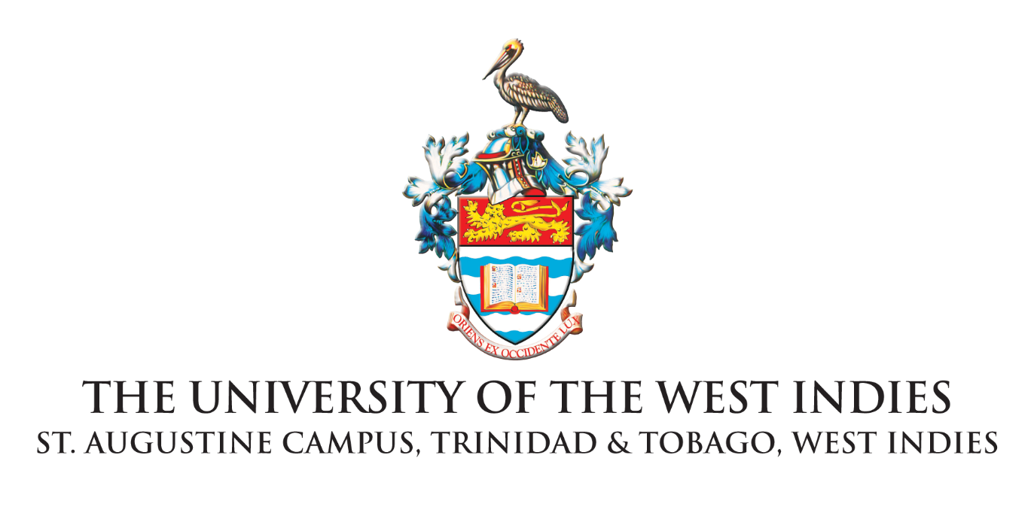
NEWS RELEASE

For Immediate Release

The IGDS, UWI calls on 2 Cents Movement
to Ensure Healing, Justice and Accountability

ST. AUGUSTINE. June 30, 2020 - The Institute for Gender and Development Studies (IGDS), The University of the West Indies, St Augustine Campus is deeply concerned about reports in the public domain that the local NGO, 2 Cents Movement, actively associated with an individual whom it is alleged committed acts of misconduct toward young women; tolerated a culture of silence and impunity despite being aware of such allegations; and failed to responsibly address concerns raised over the past four years.
"A culture of sexual violence is complex and can be treacherously subtle and difficult to negotiate, but it is real and deeply damaging. Even when accountability practices have been undertaken, an informal culture of complicity can operate with impunity. Acknowledging that this culture existed in the organisation is absolutely necessary. Whatever actions were taken did not result in prevention of harm. It is clear now that far more could have been and must now be done," said Dr Gabrielle Hosein, Head of Department, IGDS.
The IGDS has been working with the 2 Cents Movement for the past three years to provide training on gender-based violence prevention for young women and men, and to transform the normalisation of gender-based violence and sexual violence in secondary schools across the country and the region.
As one of many national partners, we call upon 2 Cents Movement to make a thorough and transparent response that is guided by truth and accountability to survivors and stakeholders, principally the school-aged children whose lives the organisation impacts. 2 Cents Movement must ensure these young people are not betrayed by the vision so poetically shared with them. Believing survivors, challenging practices of silencing, and ending tolerance of perpetrators should be the start of this process.
We know that this will be an incredibly difficult time for the young women who have not felt protected. The IGDS continues to stand with survivors of violence, and especially young women who are among the most vulnerable in our society, when they speak out as they have so courageously done. The 2 Cents Movement has a history of excellent and inspiring work, and has the opportunity to improve its capacity to create truly safe spaces and to set the best example of an organisation that grows and creates hope through taking this responsibility seriously. The way forward should bring justice and healing for those harmed, accountability, and clear organisational and management practices that ensure no girls and young women will be at such risk again. The IGDS believes in the power of these young women and men poets to do all that is necessary and right at this time.
END
About The UWI

Since its inception in 1948, The University of the West Indies (UWI) has evolved from a fledgling college in Jamaica with 33 students to a full-fledged, regional University with well over 40,000 students. Today, The UWI is the largest, most longstanding higher education provider in the Commonwealth Caribbean, with five campuses in Antigua, Barbados, Jamaica, Trinidad and Tobago, and the Open Campus. The UWI has faculty and students from more than 40 countries and collaborative links with 160 universities globally; it offers undergraduate and postgraduate degree options in Food & Agriculture, Engineering, Humanities & Education, Law, Medical Sciences, Science and Technology, Social Sciences and Sport. The UWI’s seven priority focal areas are linked closely to the priorities identified by CARICOM and take into account such over-arching areas of concern to the region as environmental issues, health and wellness, gender equity and the critical importance of innovation. Website: www.uwi.edu

(Please note that the proper name of the university is The University of the West Indies, inclusive of the “The”, hence The UWI.)

The Marketing and Communications Office
The University of the West Indies St. Augustine Campus • St. Augustine, Trinidad and Tobago
Telephone: (868) 662-2002 Exts. 82315/82316/82323/82324/82013/82014
Fax: 645-6396/662-3858 email: marketing.communications@sta.uwi.edu

