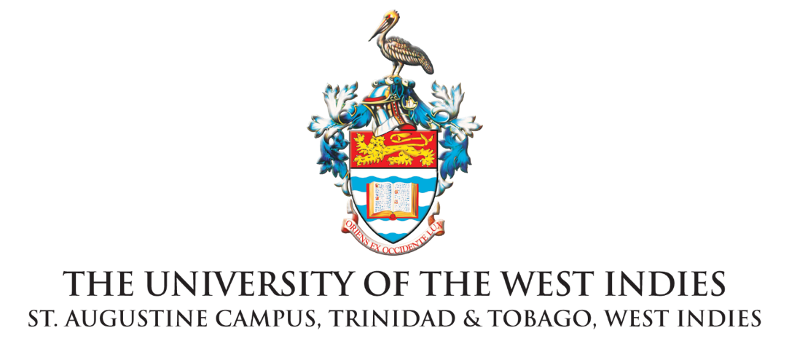
Institute for Gender and Development Studies, St Augustine Unit
RELEASE

For Immediate Release

IGDS Announces the Inaugural Regional Graduate Research Symposium
carded for Thursday 26th May 2022

ST. AUGUSTINE, Trinidad and Tobago. Monday 23rd May, 2022
The IGDS is pleased to announce the Inaugural Regional Graduate Research Symposium, which will showcase the presentations by eight graduate students from across three IGDS Units and UWI Campuses (Nita Barrow Unit, Cave Hill Campus, Barbados; Regional Coordinating Office, Mona Campus, Jamaica; and St Augustine Unit, St Augustine Campus, Trinidad and Tobago) under the themes 1) Interrogating Caribbean Masculinities; 2) Race. Gender. Body. Media; and 3) Love, Leadership and Gender Justice.

As a regional teaching institute, the IGDS has embarked on close to 30 years of cutting edge pedagogical innovations in the broad area of gender and development studies. For the IGDS, knowledge production for Caribbean development is not only done through the research and publication of staff members, but through the keen work of graduate students. It is important for such graduate work to be showcased to a regional audience in order to show the innovative research being done by IGDS graduate students from across the region.

We invite all members of the public and The UWI community to join us on Thursday 26th May 2022, 10:00 AM AST Time (Trinidad/Barbados) or 9:00 AM ECT Time (Jamaica/Eastern Caribbean) via Zoom for the Inaugural IGDS Regional Graduate Research Symposium. All are welcome. We especially invite all those interested in finding out more about graduate studies at the Institute, whether local, regional or international. Applications for a new cohort at St Augustine Unit is open currently and we welcome new graduate students who are interested in gaining professional and research experience in the fields of gender and development and interdisciplinary gender studies.

The Symposium is divided up into three panels with IGDS graduate students as chairs and IGDS faculty as discussants. For the full programme, abstracts and more information please go to the IGDS website https://sta.uwi.edu/igds/postgraduate-studies, to the facebook event https://fb.me/e/37UVLrpD3. A link will be sent out to registrants with the full programme booklet and it will be available online at https://issuu.com/igdssau/docs/igds_gradsymposium2022_programme1.
For the St Augustine Unit and Campus, if you have any questions about the symposium, or in relation to any of our programmes please do not hesitate to contact us at the following email address: igdsgraduatestudies@sta.uwi.edu Contact information for all the regional IGDS Graduate Studies Coordinators will be noted in the programme and in the Chat on the Zoom event.

To register for the Inaugural Regional Graduate Research Symposium on Zoom, click here:
https://zoom.us/webinar/register/WN_5u4Z-3rXSvOeHfJm4k8ctA
___________________________________
About Postgraduate Studies at the IGDS
The IGDS covers many fields of gender-based research and continues to provide a coherent base for trans-, multi- and interdisciplinary research on women, men and gender in areas of international and regional importance. Gender and Development Studies as an interdisciplinary field seeks to understand the complexity of Caribbean gender relations and its interactions with economic, social, political, cultural and ecological systems – in other words, the subsystems that constitute Caribbean political economy, environment and society.

The ideal IGDS graduate will have a desire for knowledge, strong critical thinking and problem solving skills, competence in interdisciplinary gender analysis, and the ability to apply theory to policy and to everyday practices. The graduate will be actively committed to social justice, valuing both diversity and collaboration. The graduate will also understand that evaluating gender difference is central to self-awareness and a commitment to the transformation of unequal power relations.

To find out more about Postgraduate Studies at the IGDS here:
https://sta.uwi.edu/igds/postgraduate-studies

END

Institute for Gender and Development Studies
The University of the West Indies St. Augustine Campus • St. Augustine, Trinidad and Tobago
Telephone: (868) 662-2002 Exts. 83577 / 83572 / 82533 Email: igds@sta.uwi.edu
Website: https://sta.uwi.edu/igds/

