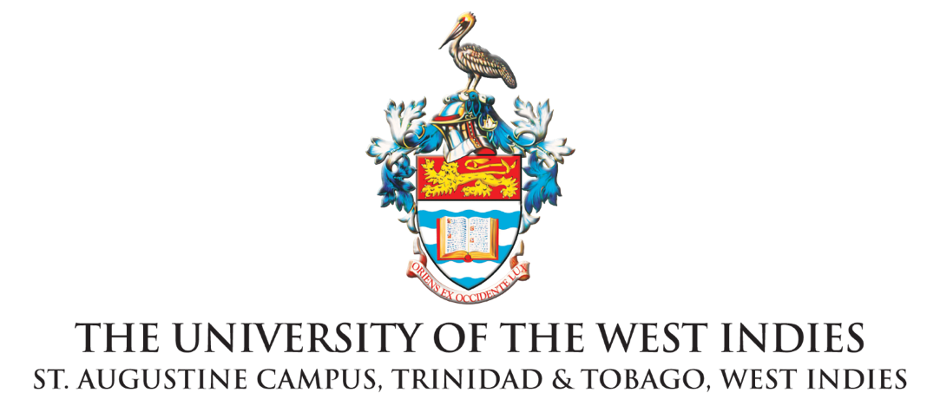
STATEMENT

For further information, please contact the Marketing and Communications Office at The UWI St. Augustine Campus via email at Marketing.Communications@sta.uwi.edu
-------------------------------------------------------------------------------------------------------------------------------------------------------
For Immediate Release

Applause for Child Sexual Abuse and Gender-Sensitive
Age-Appropriate Sexuality Education; it is long overdue

ST. AUGUSTINE, Trinidad and Tobago. Thursday 10th December 2020. The following statement is issued by Professor Rhoda Reddock, Lead Researcher of the Break the Silence: End Child Sexual Abuse Campaign of the Institute for Gender and Development Studies at The UWI St. Augustine Campus.

The discussion on age-appropriate sexuality education is taking place during the COVID-19 pandemic where we are witnessing an amazing increase in reports of child sexual abuse and other forms of gender-based violence. The Children’s Authority reports annually that sexual abuse is the most prevalent form of child abuse in Trinidad and Tobago and this reality has been brought home to us in the numerous reports in the daily press. This is all occurring in the period of Universal Children’s Day on November 20th, 16 Days of Activism against Gender based Violence and November 25th the Day for the Elimination of Violence against Women.

In this context therefore The Break the Silence: End Child Sexual Abuse Campaign congratulates all those working towards the introduction of a comprehensive age- appropriate sexuality education in Trinidad and Tobago. This is long overdue. In a society where children are sexually abused virtually from birth and where the main abusers are family members it is foolhardy to expect those same persons or persons who have been unable to provide safety in homes, to fulfil this responsibility. Indeed, this absence is in part one of the reason for the high prevalence of this child sexual abuse (CSA) including intrafamilial sexual abuse in this society. The evidence from all parts of the world is that sexuality education empowers children and young people by providing the information needed to make better decisions related to their bodies and their sexuality. This would be true for potential victims, potential perpetrators and their parents and family members.

It is important to remind the community, parents, state officials and health workers that among the effects of child sexual abuse are - physical and psychological trauma and subsequent psychopathology which often result in poor sexual decision-making and self-harm.

In a 2009 study carried out among young university students in Trinidad and Tobago, students described our society as “saturated with sex,” yet it was riddled with deep contradictions, especially in relation to expectations of males and females. While young women learnt about sex from older female relatives – mothers, aunts, sisters, cousins, especially in relation to menstruation, (one as late as age 18). This was true for some young males who also included “men on the block”, however most information came from television and internet pornography– As one young man stated, “watching man things” and from primary school peers (Roberts, Reddock, Douglas and Reid, 2009).

Already in 2011 in our Policy Brief on Education which was shared with state officials and is available on our webpage – https://sta.uwi.edu/igds/breakthesilence we observed that young people in Trinidad and Tobago are negotiating an increasingly complex and confusing social, technological, sexual and gendered space where a globalized media presents powerful hypersexual visual and musical messaging. This occurs in a context where education about gender, sexuality and sexual rights is limited; and messages about sex and sexuality are received, understood and addressed in challenging ways.

The response of the education system in the country to issues that negatively impact individuals' fundamental social and sexual experiences such as rape, child sexual abuse (CSA) and incest is generally inadequate and specifically fails to address the relationship between sexual violence and HIV risk [and we can add early pregnancy]. Appropriate education is a powerful primary prevention tool, which can reduce the risk of a range of psychological and physiological impacts, stigma, discrimination, disempowered sexual decision-making all of which may impair the ability of young persons to reach their full potential.

Our recommendations at that time were:

- Sexuality education and ways of teaching about gender and sexualities, including the recognition and management of CSA and incest, and the underlying legal framework, must be compulsory components of all teacher education programmes at the University of the West Indies and the University of Trinidad and Tobago. For teachers, principals and guidance officers who have already been trained, compulsory follow-up workshops are proposed.

- Put mechanisms in place to properly implement the Health and Family Life Education curriculum and its gender and sexuality components which include information that helps prevent and protect against CSA, HIV and drug use. This requires a serious commitment of resources and investment by the state to ensure it is valued and seen as a legitimate subject with long-term social and economic benefits. It is recommended that specialist HFLE teachers be employed with professional training to appropriately administer these programmes.

- Teachers should be formally trained to include media literacy in the curriculum for students at all educational levels. Students highly influenced by media messaging and imagery need to learn to critically evaluate the sexual messages and stereotypes with which they are bombarded.

- The Ministry of Education should revisit the national school policy on CSA and incest with an aim to revising and adopting more detailed, uniform, gender-sensitive and child friendly protocols for reporting and interviewing. Part of this initiative should include consideration and adoption of protocols created by key Trinidad and Tobago stakeholders at a 2009 workshop at UWI, St. Augustine and the Division of Education, Youth and Sport in Tobago related to CSA and incest. Teacher training and monitoring sessions are recommended during and after implementation of new policies/protocols.

These recommendations, made close to ten years ago, were not the first. They were additions to those of a long line of educators, health officials, HIV/STI advocates and numerous others who realise the efficacy of this policy and practice. Our main contribution is that these must be gender-sensitive and requires collaboration with the Division of Gender and Child Affairs of the Office of the Prime Minister. We have asked for decisions on age-appropriate sexuality education for children and to revisit the National School Policy on Child Sexual Abuse.

I trust that those responsible will have the political will to do the right thing at this critical time in our history. Again, it is long overdue.

END

About The UWI
For more than 70 years The University of the West Indies (The UWI) has provided service and leadership to the Caribbean region and wider world. The UWI evolved from a university college of London in Jamaica with 33 medical students in 1948 to an internationally respected, regional university with near 50,000 students across five campuses: Cave Hill in Barbados; Five Islands in Antigua and Barbuda; Mona in Jamaica, St. Augustine in Trinidad and Tobago; and an Open Campus. Times Higher Education has ranked The UWI among the top 1,258 universities in world for 2019, and the 40 best universities in its Latin America Rankings for 2018 and 2019. The UWI is the only Caribbean-based university to make the prestigious lists.

As part of its robust globalization agenda, The UWI has established partnering centres with universities in North America, Latin America, Asia, and Africa including the State University of New York (SUNY)-UWI Center for Leadership and Sustainable Development; the Canada-Caribbean Studies Institute with Brock University; the Strategic Alliance for Hemispheric Development with Universidad de los Andes (UNIANDES); The UWI-China Institute of Information Technology, the University of Lagos (UNILAG)-UWI Institute of African and Diaspora Studies and the Institute for Global African Affairs with the University of Johannesburg (UJ). The UWI offers over 800 certificate, diploma, undergraduate and postgraduate degree options in Food & Agriculture, Engineering, Humanities & Education, Law, Medical Sciences, Science & Technology, Social Sciences and Sport. As the region’s premier research academy, The UWI’s foremost objective is driving the growth and development of the regional economy. For more, visit www.uwi.edu.

(Please note that the proper name of the university is The University of the West Indies, inclusive of “The”)

The Marketing and Communications Office
The University of the West Indies St. Augustine Campus • St. Augustine, Trinidad and Tobago
Telephone: (868) 662-2002 Exts. 82315/82316/82323/82324/82013/82014
Fax: 645-6396/662-3858 email: marketing.communications@sta.uwi.edu

