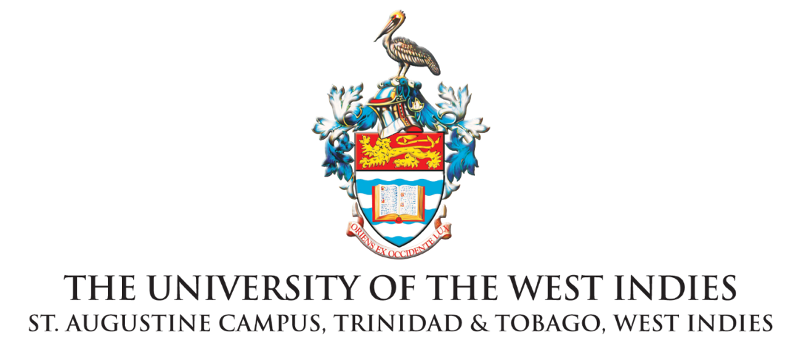
Institute for Gender and Development Studies, St Augustine Unit
STATEMENT

For Immediate Release

IGDS Calls for Stronger Actions to Protect Children
in Homes and Other Places of Safety

ST. AUGUSTINE, Trinidad and Tobago. Wednesday 3 May, 2022
The IGDS is deeply concerned about reports of children and young people who have been harmed and continue to experience high levels of insecurity within childcare residencies throughout Trinidad and Tobago. We call upon the State to act immediately on the “Safeguarding Children in Community Residencies and Child Support Centres in Trinidad and Tobago” Report and to urgently follow through on the report's recommendations. We remind the Government that this latest report – submitted in December 2021 to the Minister of Gender and Child Affairs, released to the public on 28 April 2022 – is yet another in a long list of reports on the status of children in state-funded and privately-operated homes for over two decades.

The IGDS has long produced research on the issues of Child Sexual Abuse in Trinidad and Tobago and continues to offer trainings and public information emerging from the action-research project ““Breaking the Silence (BTS): Child Sexual Abuse and Incest: A Multi-Sectoral Approach” (2008-2012). A fundamental driver of this project was the need to challenge prevailing attitudes and perceptions of CSA within Trinidad and Tobago. The project was initiated in response to concerns expressed by a wide range of stakeholders throughout Trinidad and Tobago, who acknowledged child sexual abuse’s taboo character and diverse beliefs about it across local communities. The project noted the inaction and assumed tolerance of child sexual abuse, and demanded that the situation be researched and unearthed. The ongoing work of the project includes teacher training, development of BTS toolkits, public information sessions, and capacity building with civil society and faith-based organisations.

Emeritus Professor Rhoda Reddock was the project lead researcher of Break The Silence: “One of the earliest interventions of the BTS campaign was with the then nascent Children's Authority which resulted in the inclusion of child sexual abuse as reportable category in the Authority. As a result, we are now able to track the enormity of this challenge.”

The 2021 report uncovers the pressing need for state oversight and the need for greater accountability and multi-sectoral approach to meet the needs of children (particularly those in vulnerable situations).

The IGDS uses this opportunity to remind the Government of Trinidad and Tobago of the following related to the care of children:
- In 2015, the responsibility for children’s matters was removed from the Ministry of Social Development and Family Services to the Office of the Prime Minister (OPM). All matters relating to the Children’s Authority, child development, children’s homes, special needs children, community residences, orphanages and gender affairs were placed in the Gender and Child Affairs Division in the OPM with a Minister attached and the Prime Minister as the voice of the Ministry in Cabinet.
- In 2015, the Child Protection Unit (CPU) was established within the T&T Police Service. The role and function of the CPU are to investigate sexual offences or abuse, physical abuse, abandonment or neglect and ill treatment of all children.
- Within the CPU’s first year of operation, a significant proportion of the 2,595 reports investigated involved sexual abuse, abandonment, and neglect.
- The ‘2017 Social Sector Investment Programme’, among the nine initiatives identified for the fiscal year 2017 was a government promise to invest in the modernisation of St Mary’s Children’s Home as well as policy and research initiatives.

We call on the Hon Minister to share with the national community what has happened between 2015 and now in responding to the needs of children in care facilities nationally. We call for a clear statement of the actions taken to respond to the needs of children in care facilities. In addition to an update on the formation of a task-force and action plan, we ask exactly how the task-force will respond to this latest report with immediate action and transparency. Further, in light of the complex and multifaceted nature of this challenge, the government ought to partner with civil society organisations and a more diverse range of actors in the task-force. Suitable representation of past residents of homes should be included in this task-force with related psycho-support services included and offered the past residents. We also insist that the new position of Children's Commissioner should prioritise requirements of clear qualifications, experience, and caring and human-rights approach to transformation.

We also call for a holistic approach to children as part of a larger revitalisation of the social sector and social support systems in Trinidad and Tobago. In light of this, we stress the importance of supportive approaches to children, families, households and communities to prevent them from ending up in these quasi systems of incarceration. We support calls for a strengthened student support system, the reintroduction of community social work, family social work and child social work programmes and strong parent support programmes including gender-informed parenting education programmes.

From global evidence, young people are empowered through age-appropriate gender and sexuality education programmes in schools providing the knowledge and understanding to protect themselves and make better decisions. Substance abuse and addiction is a major challenge in this society and is a major contributing factor to child abuse and family violence. We call for the revitalisation of the National Alcohol and Drug Abuse Prevention Programme and for pro-active addiction prevention and treatment programmes throughout the society. The costs of prevention are much lower than the costs of the pain, violence, and physical and other infrastructure that is required in its absence.

Finally, there must be immediate response and action to protect the children currently in these homes, where contributing there are reports of repeat sexual offences and gender based violence occurring. Crucial to this protection is thorough investigation and accountability, along with retraining on human rights approaches to child care, enhanced specialised psycho-social support, and sustained trauma interventions for children and young people.

END

Institute for Gender and Development Studies
The University of the West Indies St. Augustine Campus • St. Augustine, Trinidad and Tobago
Telephone: (868) 662-2002 Exts. 83577 / 83572 / 82533 Email: igds@sta.uwi.edu
Website: https://sta.uwi.edu/igds/

