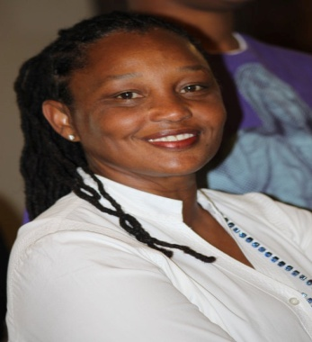
Marie Kellier

Marie Kellier is President of MARIKEL International and the Founder and Artistic Director of CARICABELA Los Angeles Carnival. She holds a Bachelor of Arts (BA) in playwriting/theater and a Master of Fine Arts Degree (MFA) in film and television production from the University of California, Los Angeles (UCLA). She is the only Caribbean National to win the Samuel Goldwyn Creative Writing Award, and in the same year, receive a Nicholl Screenwriting Fellowship from the Academy of Motion Picture Arts and Sciences Foundation. Highly impacted by improvised firelight theater in her childhood village in the Caribbean, Marie’s creative impulses drew her to create productions that showcase the arts and culture of the Caribbean. While still at UCLA, she staged the first major Caribbean arts and cultural festival on campus. She is currently one of a select group of artists representing the City of Los Angeles in residence abroad as a Cultural Exchange International artist. Marie has chosen to use this opportunity expand her knowledge as a Carnival arts professional and bring new skills to Los Angeles to increase the pool of Carnival artists available in the Greater Los Angeles area.

Marie has been interim Director of Outreach for the California African American Museum, writing several winning grants, public programs and wall texts for the museum’s exhibitions. She also worked with the late artist John Riddle as Visual Arts Assistant and continues to contribute to the museum’s programs on an annual basis. Marie has served as a consultant to the UCLA Fowler Museum, producing the Caribbean segment of Carnival UCLA!

Marie is a team player and has focused her tremendous energies and ‘can do’ spirit on developing CARICABELA Los Angeles Carnival, the largest event on the West Coast of the United States, that is dedicated to celebrating, preserving and presenting the regional arts and culture of the Caribbean on an annual basis.

