**CTLPA BREAKFAST WORKSHOP**

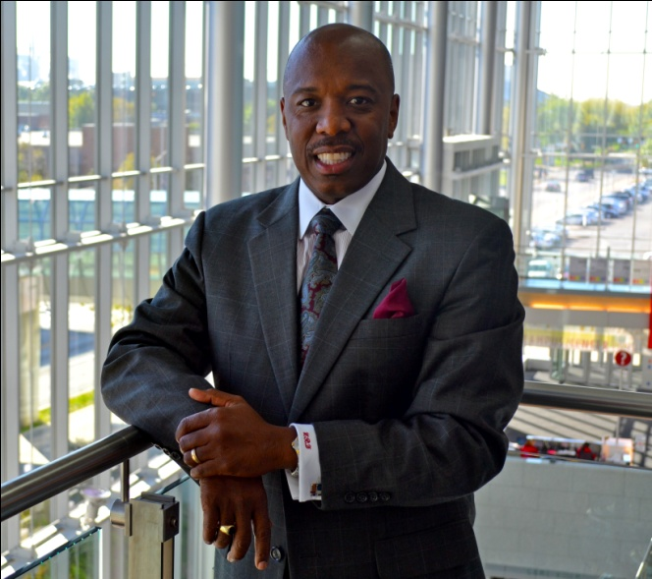[](http://www.bing.com/images/search?q=picture+of+people+in+service+learning&id=D678F4873CC266586E99FD850288A222A39DDD05&FORM=IQFRBA#view=detail&id=D678F4873CC266586E99FD850288A222A39DDD05&selectedIndex=0)Heather Shea Gasser

“***Service Learning to Build Engaged Student Citizens”***

***Dr. Zebulun Davenport and Dr. Heather Shea Gasser***

**Description of Workshop**: As members of society become increasingly more conscientious about sustainability efforts, the environment, giving to those who may be less fortunate and or bettering their spaces, community engagement, “alternative” breaks options and service-learning opportunities on college campuses are becoming increasingly more popular.  These options provide students with the opportunity to systemically and effectively contribute to the betterment of our world.  On many campuses, service learning is becoming a major component for student learning and engagement.  The fact is, these mutually beneficial experiences have proven to yield positive outcomes for faculty, staff, students and the community.  As a result, we have created an interactive workshop designed to:

* provide participants with a clear definition of service learning and civic engagement;
* explain the benefits of creating service-learning experiences for faculty, staff and students as well the community;
* identify learning outcomes;
* brainstorm a list of potential activities appropriate for this region; and
* guide participants through creating and implementing service learning experience for your constituents.

***** ***** ***** *****

***“The Impact of Mental Wellness and the Role of Peer Support Systems”***

***Dr. Sarah Chin Yuen Kee***

This Presentation aims to increase staff and students’ awareness of mental health and wellness, and its impact on an individual’s functioning and academic success

.

**The Trinidad and Tobago Chapter of**

**Presents …**

**A CTLPA Breakfast Workshop**

“SERVICE LEARNING TO BUILD ENGAGED STUDENT CITIZENS”

**Dr. Heather Shea Gasser, Assistant Director, RISE, Michigan & Dr. Zebulun Davenport, Vice Chancellor for Student Life, Indiana**

*and*

“The Impact of Mental Wellness and the Role of Peer Support Systems”

**Dr. Sarah Chin Yuen Kee, UWI,**

**ST. AUGUSTINE CAMPUS**

**Friday 17th JANUARY 2014 at 8:30am - 12:30pm Registration Begins at 8:00am**

**At the DAAGA AUDITORIUM**

**The University of the West Indies St. Augustine**

**COST:**

**Members: $200.00**

**Non-Members: $250.00**

**Who should attend?**

* Administrators
* Student Services Personnel
* All persons in contact with students

For further Information please contact us at:

[Chandra.Ragoonath@sta.uwi.edu](mailto:Chandra.Ragoonath@sta.uwi.edu)

[Kevin.Snaggs@sta.uwi.edu](mailto:Kevin.Snaggs@sta.uwi.edu)

[Sarah.Kalloo@sta.uwi.edu](mailto:Sarah.Kalloo@sta.uwi.edu);

[Chandar.Supersad@sta.uwi.edu](mailto:Chandar.Supersad@sta.uwi.edu)

Geeta. Kissoon@sta.uwi.edu

Shivonne.ChengWing@utt.edu.tt



**CARIBBEAN TERTIARY LEVEL PERSONNEL ASSOCIATION**

**THE CARIBBEAN TERTIARY LEVEL PERSONNEL ASSOCIATION**

**The Trinidad and Tobago Chapter of**

**Presents …**

**A CTLPA Breakfast Workshop**

“SERVICE LEARNING TO BUILD ENGAGED STUDENT CITIZENS”

**Dr. Heather Shea Gasser, Assistant Director, RISE, Michigan & Dr. Zebulun Davenport, Vice Chancellor for Student Life, Indiana**

and

“The Impact of Mental Wellness and the Role of Peer Support Systems”

**Dr. Sarah Chin Yuen Kee, UWI, ST. AUGUSTINE CAMPUS**

**Friday 17th JANUARY 2014 At 8:30am - 12:30am Registration Begins at 8:00am**

**At the DAAGA AUDITORIUM The University of the West Indies St. Augustine**

**COST:**

**Members: $200.00**

**Non-Members: $250.00**

**Who should attend?**

* Administrators
* Student Services Personnel
* All persons in contact with students

For further Information please contact us at:

[Chandra.Ragoonath@sta.uwi.edu](mailto:Chandra.Ragoonath@sta.uwi.edu)

[Kevin.Snaggs@sta.uwi.edu](mailto:Kevin.Snaggs@sta.uwi.edu)

[Sarah.Kalloo@sta.uwi.edu](mailto:Sarah.Kalloo@sta.uwi.edu);

[Chandar.Supersad@sta.uwi.edu](mailto:Chandar.Supersad@sta.uwi.edu)

Geeta. Kissoon@sta.uwi.edu

Shivonne.ChengWing@utt.edu.tt

