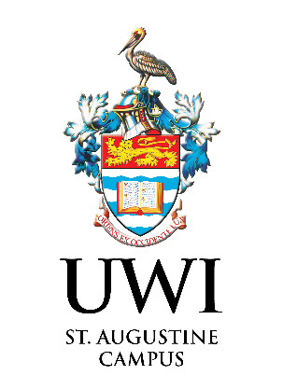
PRINCIPAL’S Research Awards 2026
Principal’s Special Innovation Award
Application Form

To be completed and submitted to the Research Awards Application Portal at https://sta.uwi.edu/researchawards/applications/ on or before 11.59 pm of Monday 28 September 2026 for consideration by the Campus Research Awards Committee. If you have any challenges submitting your application, please email STA-research.awards@sta.uwi.edu

IMPORTANT INFORMATION
This award is open to ALL researchers and innovators across the country including all Tertiary Institutions and Secondary School teachers and Students who have embedded in innovative research and developed the product/outcome that has greater potential for commercialization. The prime objective of this award is to recognize the innovation and to motivate all researchers who contribute to research and technology innovation.
Application Guidelines
- Open to:
  - Researchers and innovators across Trinidad and Tobago, including those affiliated with, Public and private sector institutions and organizations, Secondary schools (teachers and students), Industries and communities
  - All researchers at The UWI St Augustine, including Academic Staff, ASAP (Academic and Senior Administrative Professional) Staff and ATSS (Administrative, Technical and Service Support) Staff
- Awardees under this category for the Principal’s Research Awards in 2023, 2024 and 2025 editions are not eligible to apply.
- There is no limit to the number of awards an applicant may receive, however, the same research work or the Project will not be considered for more than one award.
- Applicants are responsible for ensuring the accuracy of information provided in the application form.
- Only applications submitted using the relevant award Template will be considered.
- The decision of the Campus Research Awards Committee is final, and it reserves the right to verify statements made on the application form and to not award a specific category based on its merit and suitability of application.
- Applications should be submitted with a cover letter clearly indicating the name of the award being applied for in Word or PDF format.
- Awardees will be invited to present their research post-award ceremony on the scheduled day and time for the benefit of all researchers and external stakeholders to showcase the impact of research being undertaken at the Campus.
- Submit Application to the Research Awards Application Portal at https://sta.uwi.edu/researchawards/applications/ on or before 11.59 pm of Monday 28 September 2026. No late submissions will be accepted.
- Should you have any queries or require any clarification, kindly send an email to STA-research.awards@sta.uwi.edu
- For more information on Principal’s Research Awards, please visit the website: https://sta.uwi.edu/researchawards/

Application Details
APPLICATION FOR … ………………………………………………………………..
- Name of Innovator: [Please insert]

- Position of Innovator: [Please insert]

- Name of Innovator’s Organisation (If applicable): [Please insert]

- Contact details of the Innovator: [Please insert]

- Research Experience (If applicable): [Please insert]

- Describe the invention/discovery/innovation made (Not exceeding 500 words)

- Proof of product output for potential commercialisation, trademark, copyright, or patent protection for the innovation, demonstrating its uniqueness and potential for broader impact (Please include supporting statements and evidence (publications), as far as possible)

- Impact of innovation contribution to societal improvement /environmental sustainability (Please include evidence/Testimony/Certificate /supporting statements from the end users)

- Statement of nomination for the PRINCIPAL’S SPECIAL INNOVATION AWARD (Please state why you should be considered for this award. This statement of nomination should not exceed 1500 words)

Signature of Applicant |  | Date

